Govt. Degree College Thannamandi

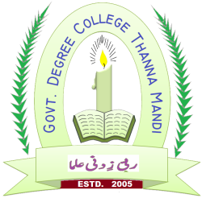

Annual Report July 2024-March 2025
National service Scheme
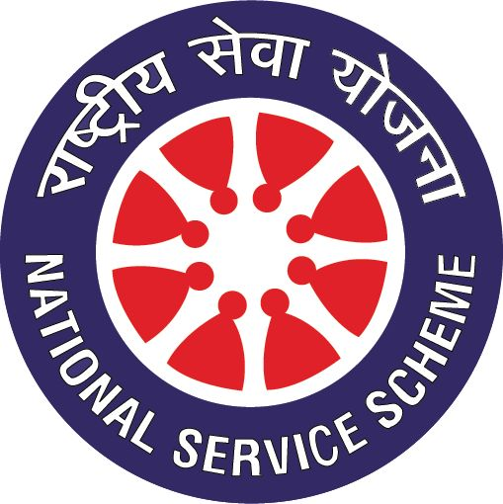

Prof Supriya Gupta NSS PO

Govt. Degree College Thannamandi Organizes Essay Competition on Cyber Security
Thannamandi, July4, 2024: The Department of Computer Science in collaboration with NSS Unit, Government Degree College Thannamandi organized an online essay competition on the topic “Cyber Security and its Importance” on Wednesday, July 3rd 2024 under the patron ship of the Principal of the college, Prof. Dr. Farooq Ahmed. The competition was one of the series of monthly events organized in the Institution under the programme “Cyber Jagrukta Awareness Diwas” a program by the Ministry of Home Affairs and Higher Education Department J&K for implementing the scheme called "Indian Cyber Crime Coordination Centre (I4C)".10 Students participated in the competition in which the students expressed their views on Cyber related crimes and security. Umar Farooq and Mohd Rafiq students of Govt. Degree College Thannamandi bagged the first position, Nidaa Qaisar adjudged as second and Zulfikar Ali student of Govt. P. G. College Rajouri got the third position. Prof Supriya Gupta, HOD Computer Science and Nodal officer Cyber Jagrukta awareness programme of the college organized the programme.

Plantation Drive
GDC Thannamandi, 18.07.2024: The College Beautification Committee in Collaboration with NSS Unit of the college organized a plantation drive. This initiative, conducted under the guidance of Dr. Farooq Ahmed Principal of the college, in order to save earth from global warming and human deeds like a-forestation students planted trees in their campus area and the surroundings.

Registration of NSS Volunteers and other students on MYBHARAT portal.
56 students have been successfully registered on My Bharat portal and the process will continue till the college admissions will be completed.

Govt. Degree College Thannamandi observes Swachhta Pakhwara from August 1-14, 2024
Govt. Degree College Thannamandi observed Swachhta Pakhwara from August 1-14, 2024 with a series of events and activities aimed at promoting cleanliness and hygiene on campus. NSS unit of the College under the leadership of worthy Principal Prof Dr. Farooq Ahmed will organize series of events like - Cleanliness drives in classrooms, laboratories, and common areas, Poster-making and slogan-writing competitions on swachhta themes, Plantation drive, Cleanliness drives in nearby water bodies etc.
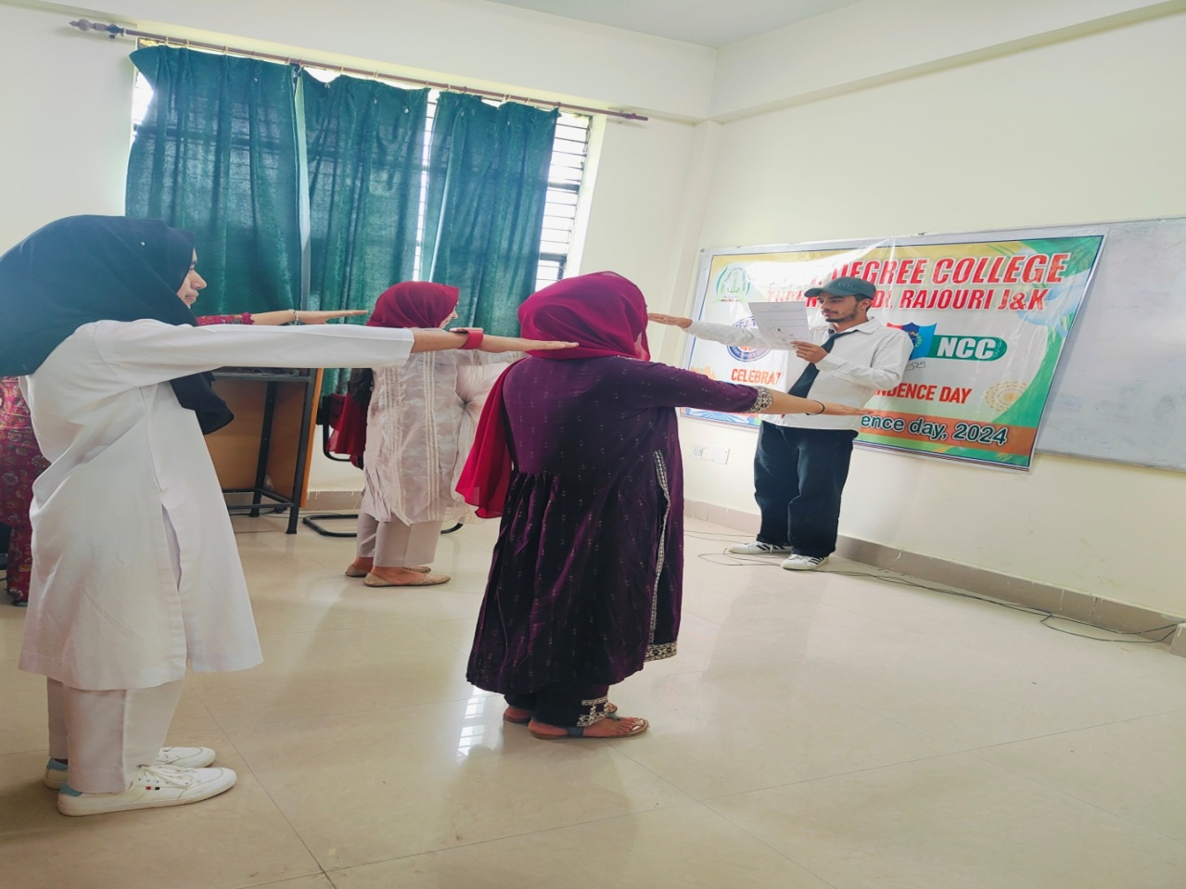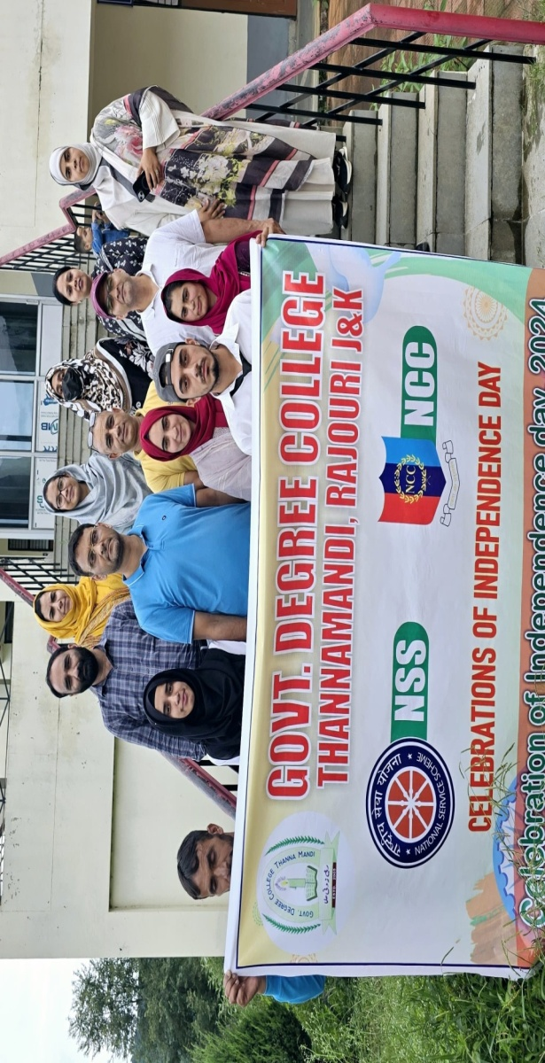

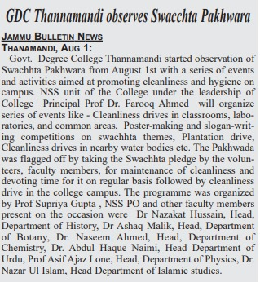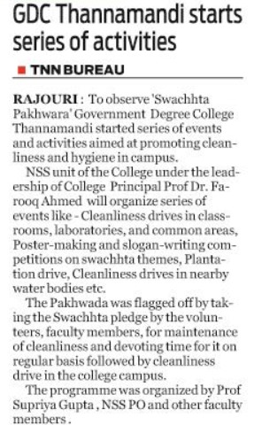

Plantation Drive: Ek Ped Maa ke Naam

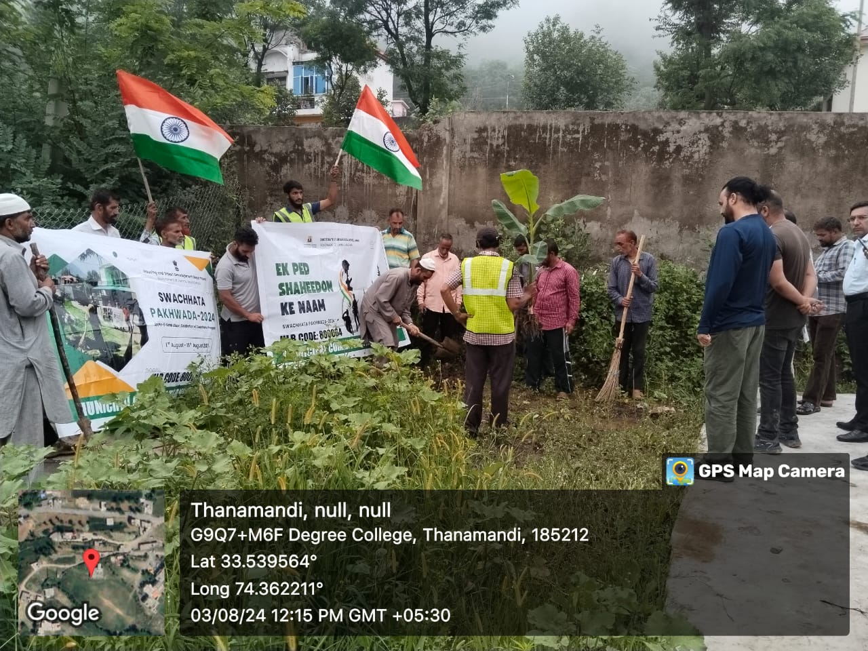

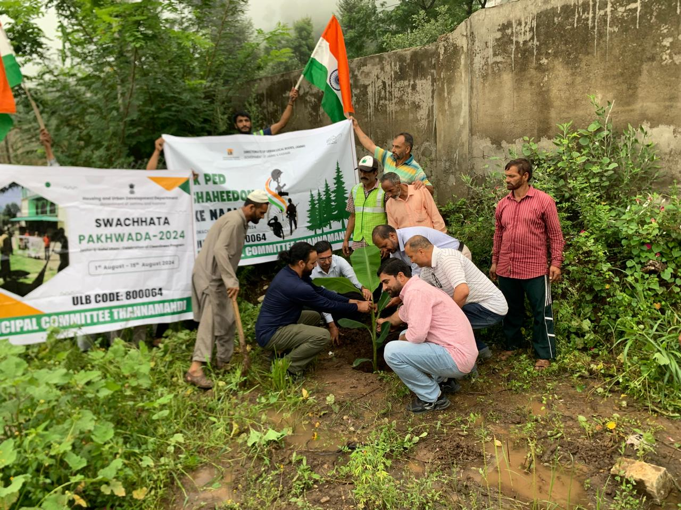

Cleaning of nearby water bodies:

Cleanliness Drive was organized at Fresh Water Spring at Majhur near Govt. Degree College Thannamandi, Rajouri. by NSS Unit of the College under the proficient guidance of Principal of the College Prof Dr Farooq Ahmed. Twenty NSS Volunteers along with programme officer Prof Supriya Gupta visited the fresh water springlocated at a distance of 3 KM from the college campus which is the source of drinking water to the local residents. The volunteers removed trash, debris, and a weed from the water body with great enthusiasm.The surrounding area was cleaned, by removing litter and waste. Locals were educated about the importance of maintaining clean water bodies and the impact of pollution.
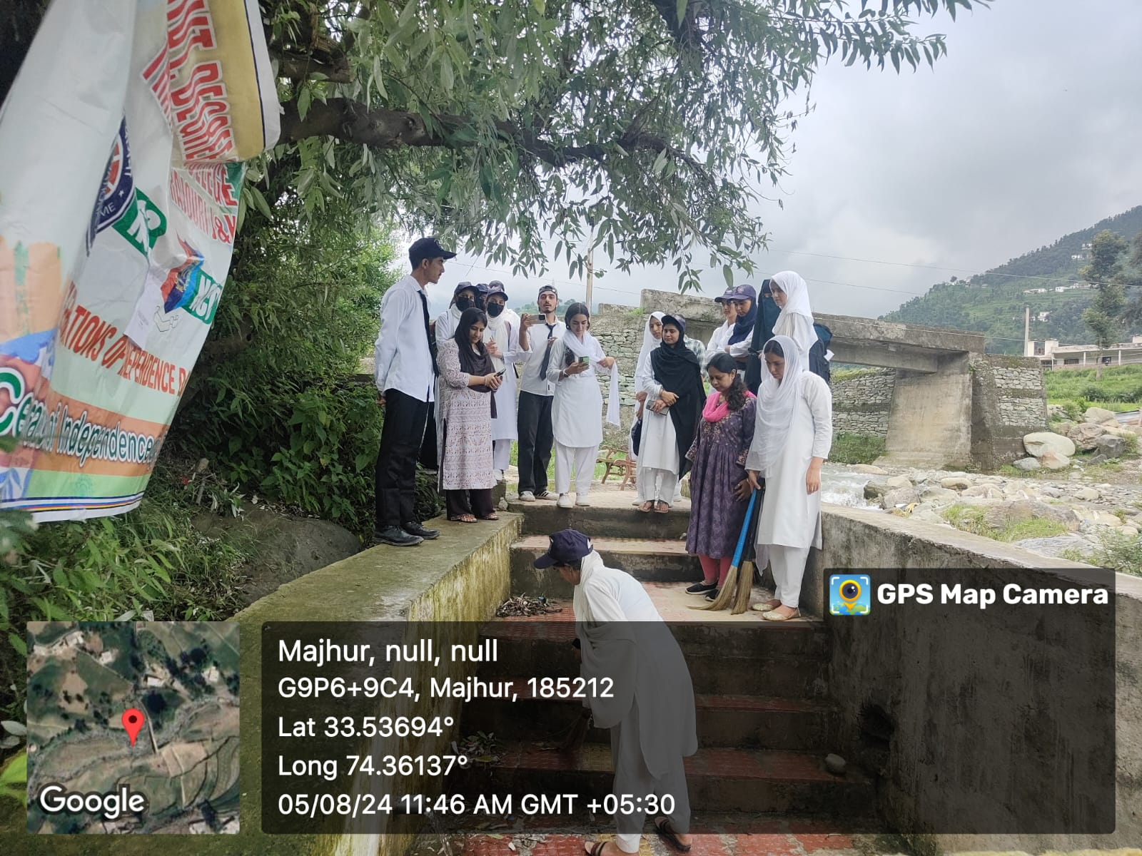
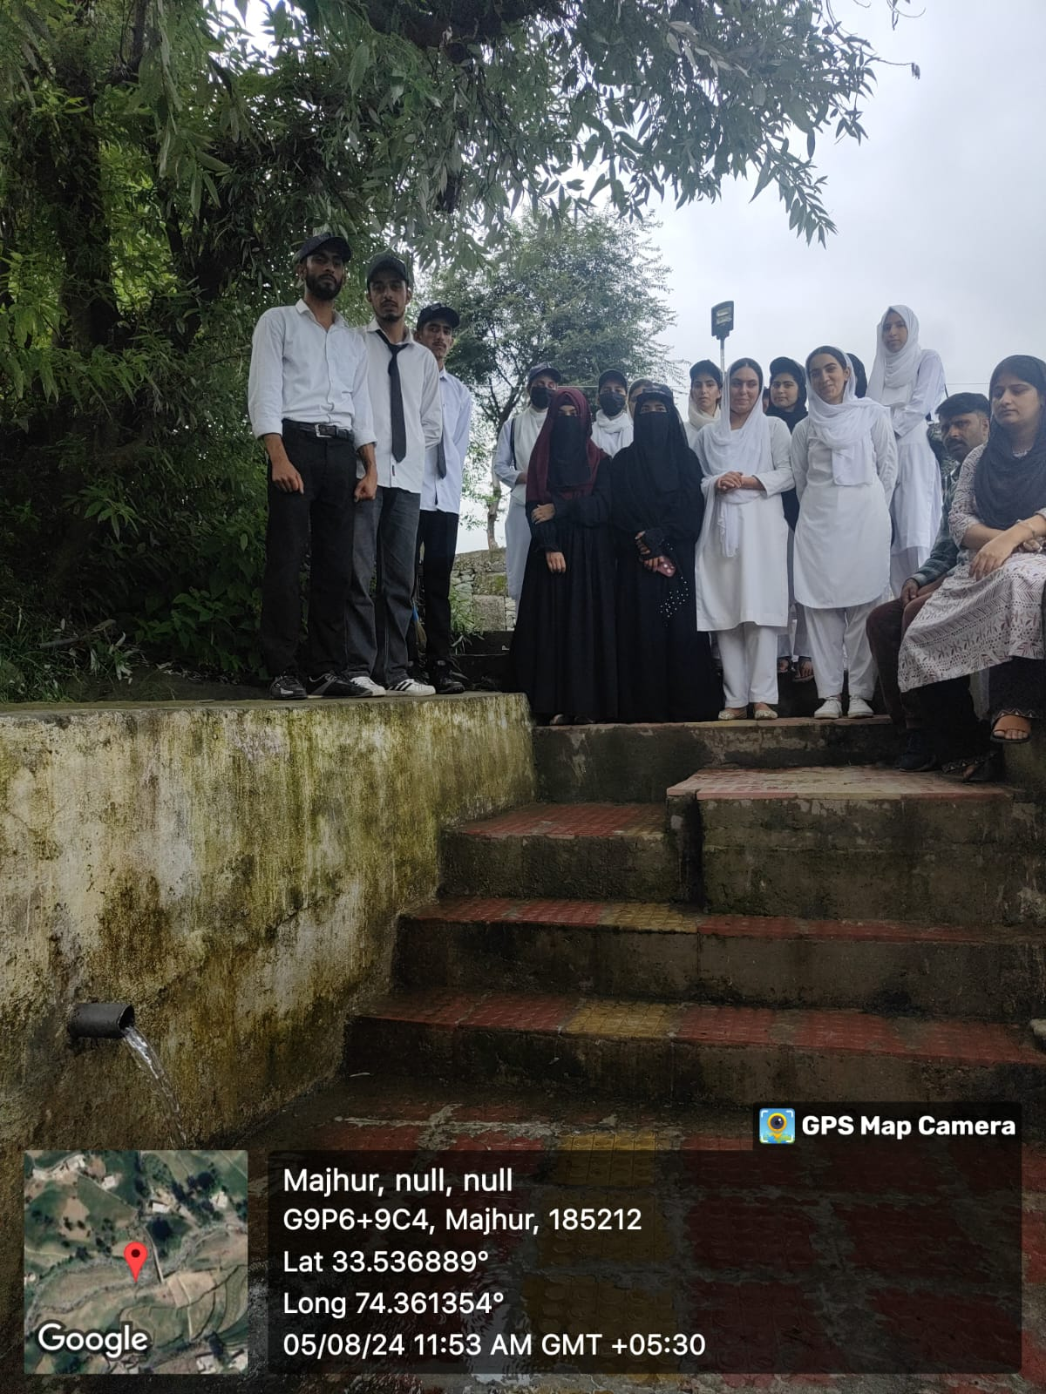
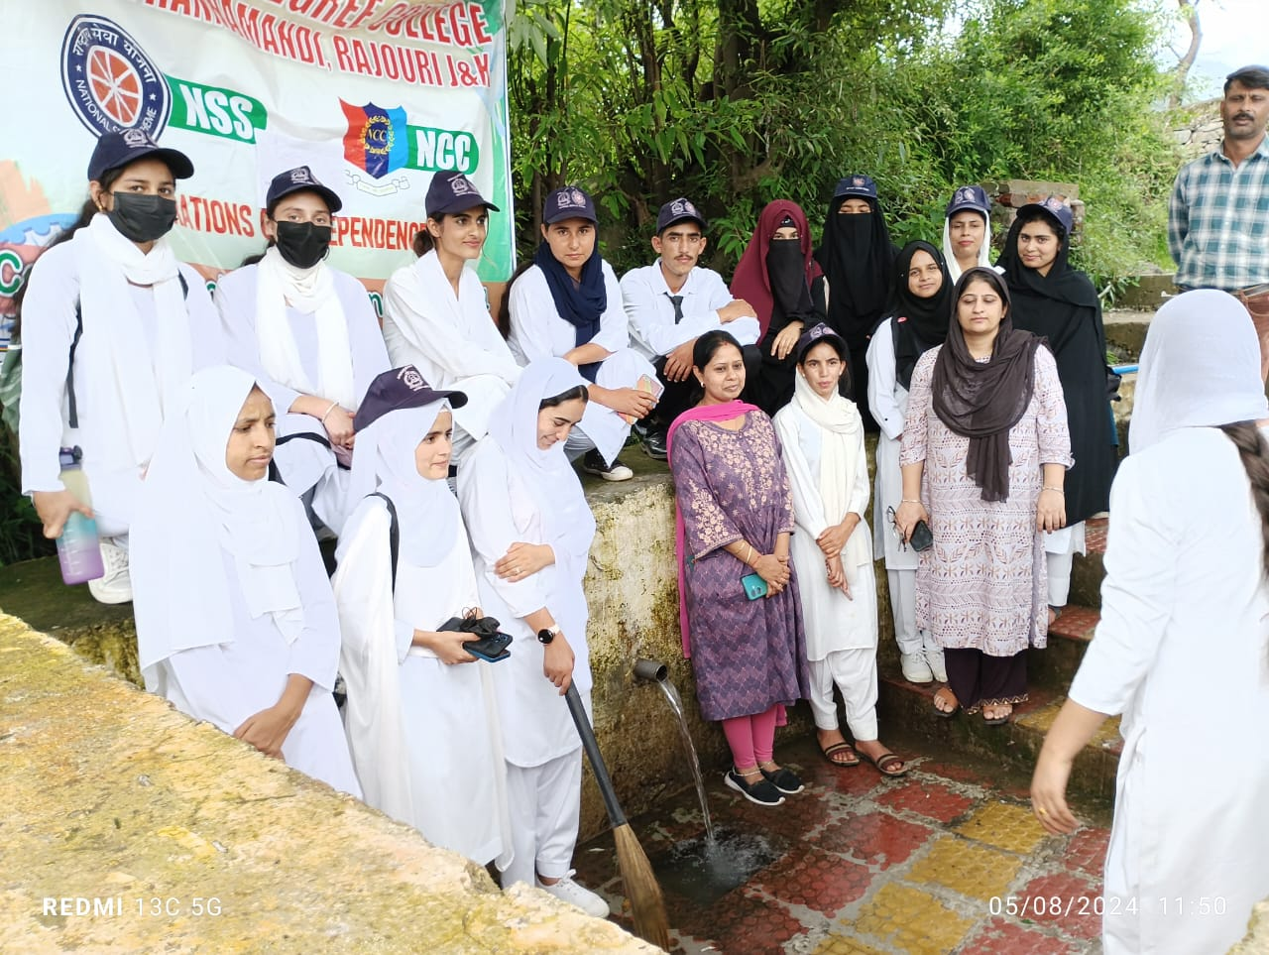

- Painting Competition On The Theme Viksit Bharat 2047 :

Painting Competition on the theme Viksit Bharat 2047 was organized at Govt. Degree College Thannamandi, by NSS Unit of the College under the proficient guidance of Principal of the College Prof Dr Farooq Ahmed. Twenty NSS Volunteers showcased their artistic skills through paintings depicting various aspects of Viksit Bharat, such as:
- Clean environment
- Modern infrastructure
- Technological advancements
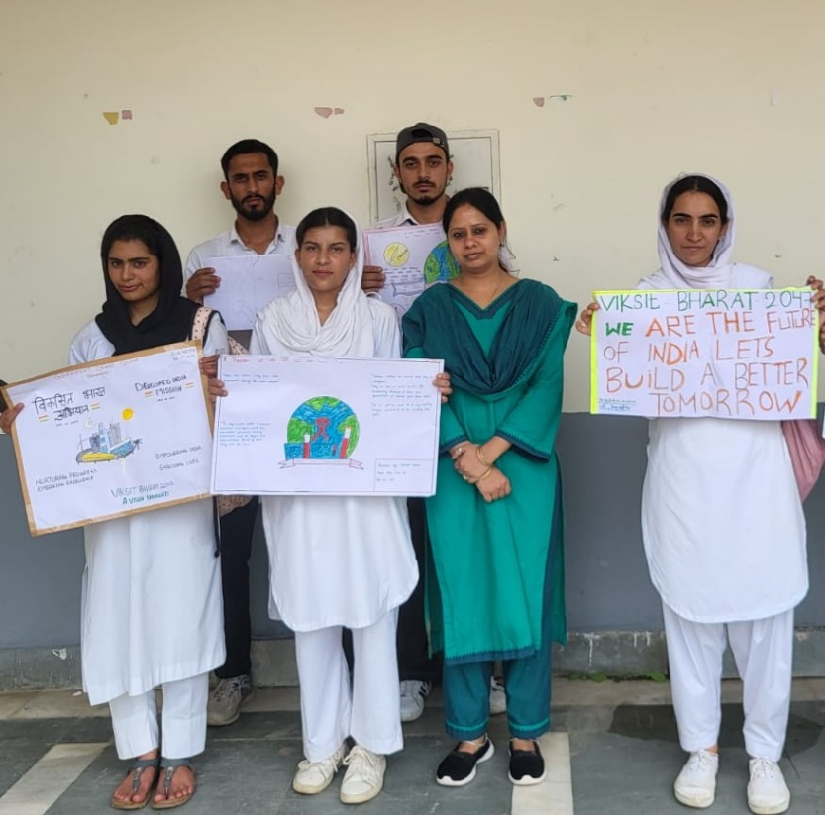

Essay Writing Competition On The Topic “The Unsung Heroes Of Freedom Struggle:

An Essay Writing Competition on the Topic “The Unsung Heroes of Freedom Struggle” organized was at Govt. Degree College Thannamandi, Rajouri by NSS Unit of the College in collaboration with the College Cultural Club under the proficient guidance of Principal of the College Prof Dr Farooq Ahmed. Fourteen NSS Volunteers submitted essays that highlighted the contributions of unsung heroes, such as:
- Freedom fighters
- Social reformers
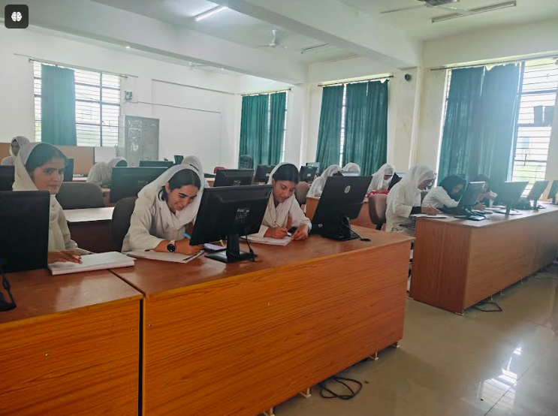
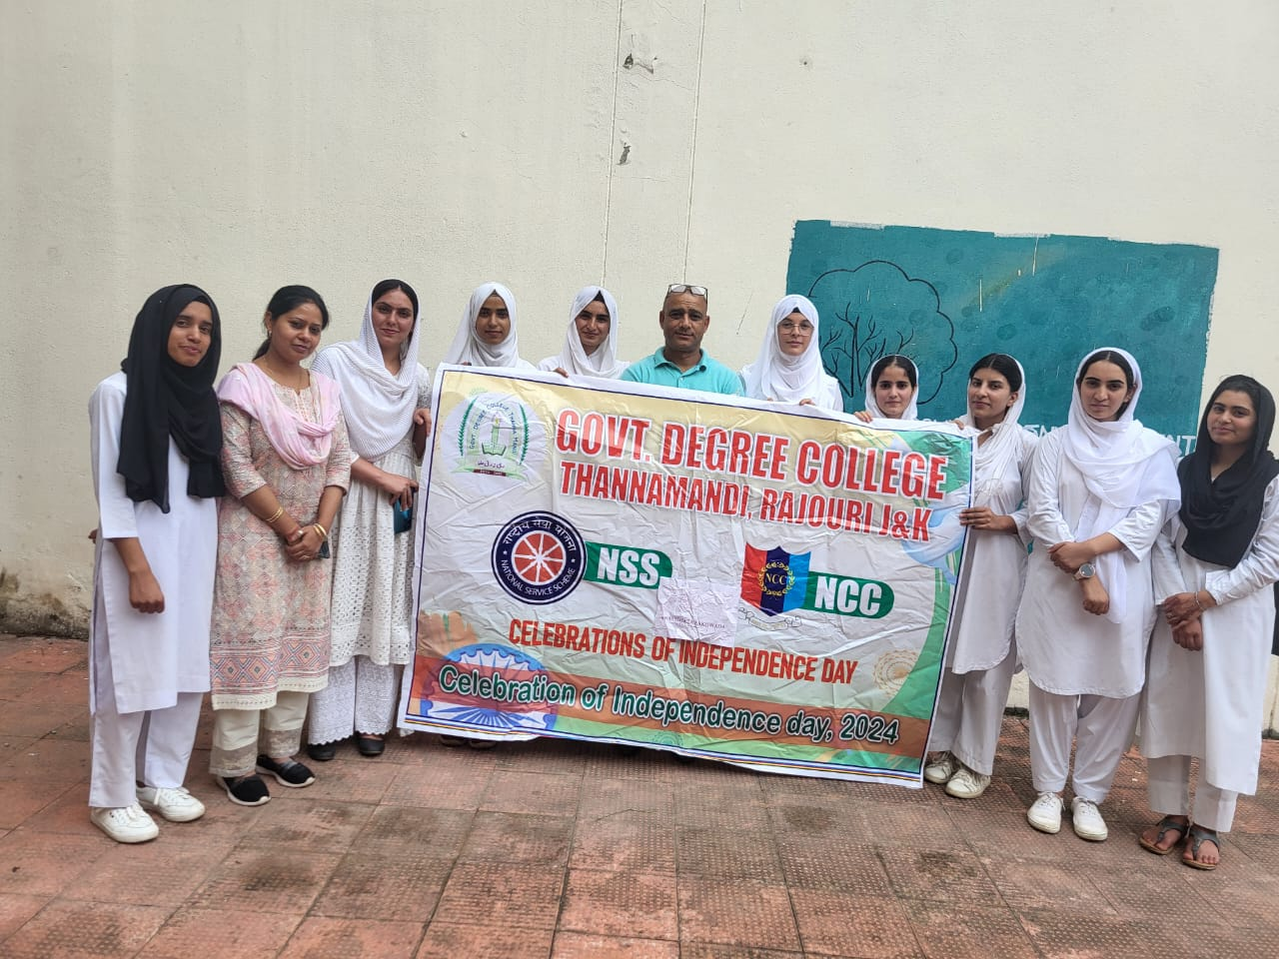

Tiranga Rally& Poster Competition To Celebrate International Youth Day
NSS Volunteers participated in Tiranga Rally to celebrate Independence day and participated in poster making competition to commemorate national Youth day on August 12, 2024
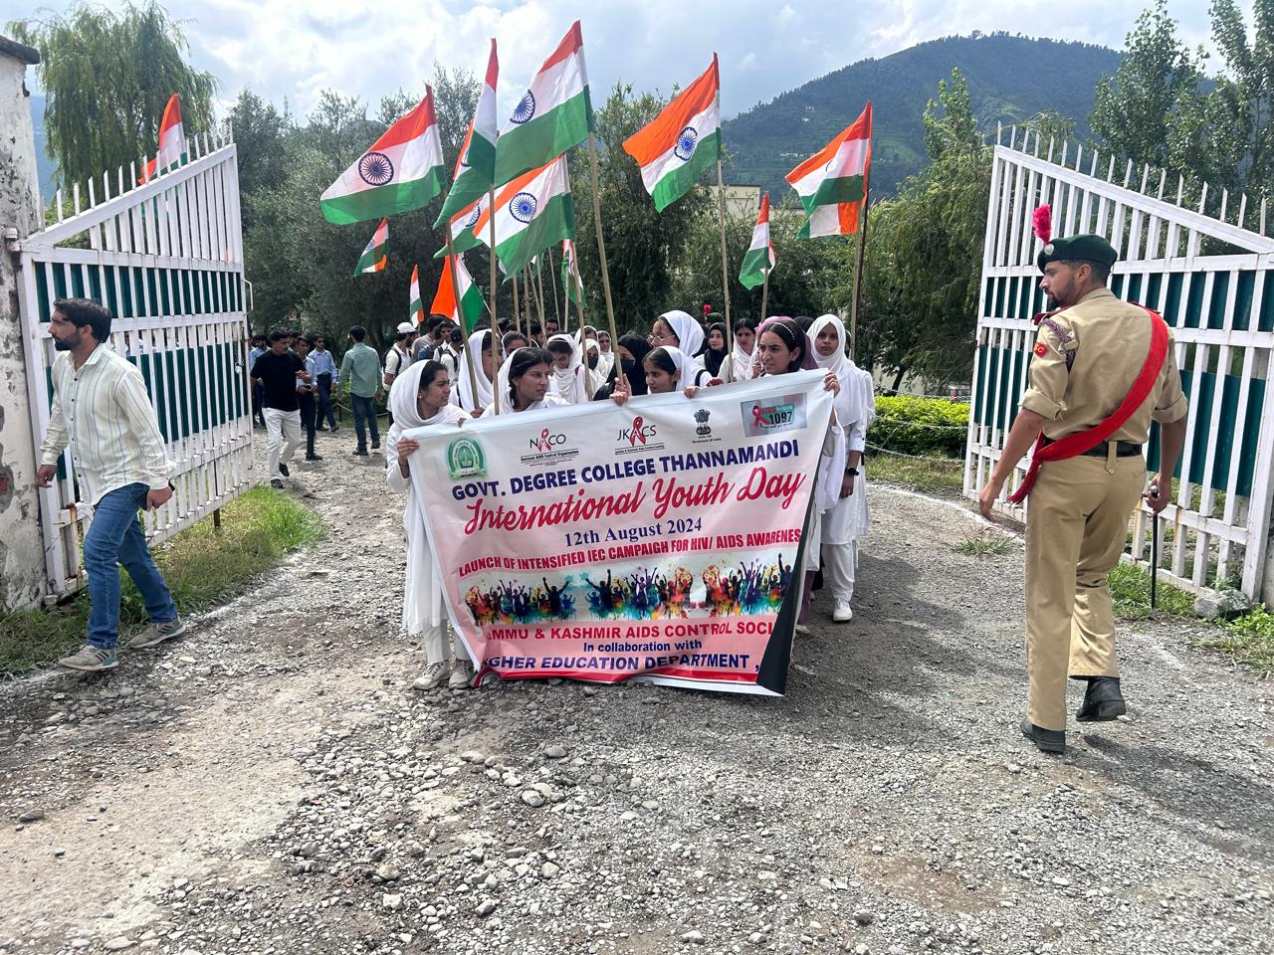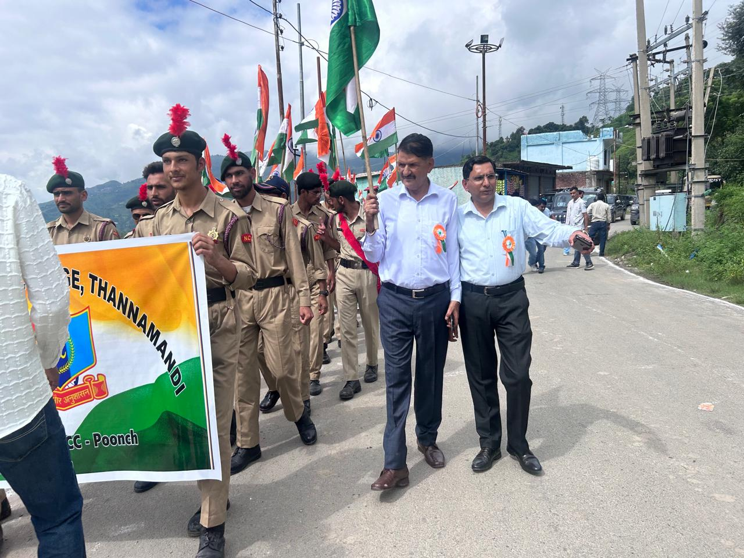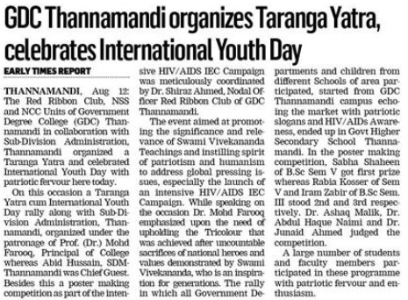

NASHA MUKT BHARAT ABHIYAAN: MASS PLEDGE FOR NASHA MUKT BHARAT
While joining the nation in combating the drug abuse, the Red Ribbon Club in collaboration with NSS and NCC Units, and Departments of Botany and Zoology of Government Degree College (GDC) Thannamandi participated in the Country Wide Mass pledge on Nasha Mukht Bharat Abhiyan and conducted Plantation Drive.The entire college including students, teaching and non-teaching staff members participated through video conferencing in Country Wide Mass pledge on Nasha Mukht Bharat Abhiyan.The programme was followed by Anti- Drug Human Chain and plantation drive under the theme Viksit Bharat ka mantra, Bharat ho nashe se swatantra in which each faculty member and NSS/Red Ribbon Club Volunteer/ NCC cadet planted a sapling dedicated to Nasha Mukh Bharat Abhiyan. 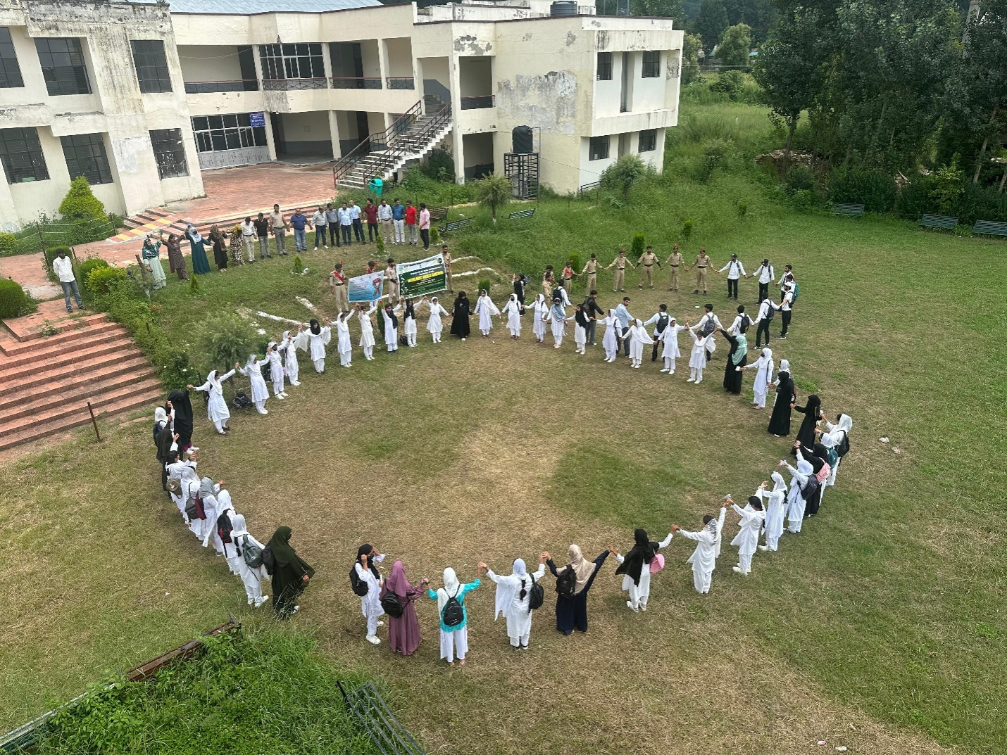

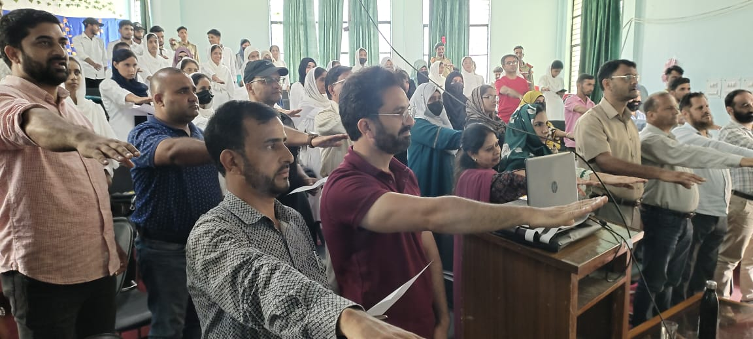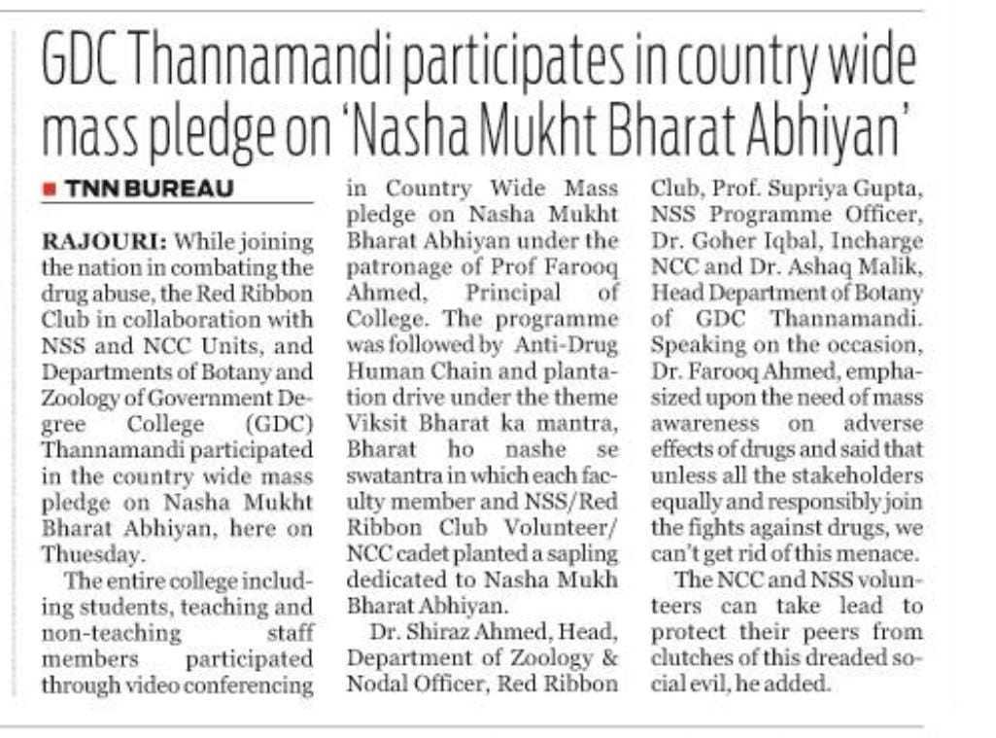

INDEPENDENCE DAY CELEBRATIONS
Govt. Degree College Thannamandi celebrated the 78th Independence Day with great joy and the sense of happiness and pride could be clearly seen on the faces of all the students and faculty members present on the occasion. The program started with the unfurling of National Flag by the worthy principal of the college Prof Dr Farooq Ahmed in presence of other faculty members and students of the college together at 7:30 AM. As soon as the flag was hosted, NSS volunteers sang the National Anthem and everyone sang with them.

- Symposium on the topic “"The Evolving Role of Teachers in the Modern Era," to celebrate Teacher’s day
Thannamandi, September 6th, 2024: The National Service Scheme (NSS) unit of Government Degree College (GDC) Thannamandi, in collaboration with the Cultural and Literary Committee, organized a grand celebration to mark Teachers' Day. The celebration began with a welcome address by Dr. Naimi followed by symposium on the topic "The Evolving Role of Teachers in the Modern Era," where students presented their thoughts and ideas about the changing role of teachers from traditional classroom teaching to that of a facilitator. The winners were awarded mementos and certificates, while all participants received certificates of participation. Students also showcased their talent through songs and poetry, paying tribute to their teachers.The chief guest, Dr. M.B. Magray, emphasized the significance of teachers in shaping the future of society. The guest of honor, Mr. Mir Muzaffer, also shared his valuable insights.
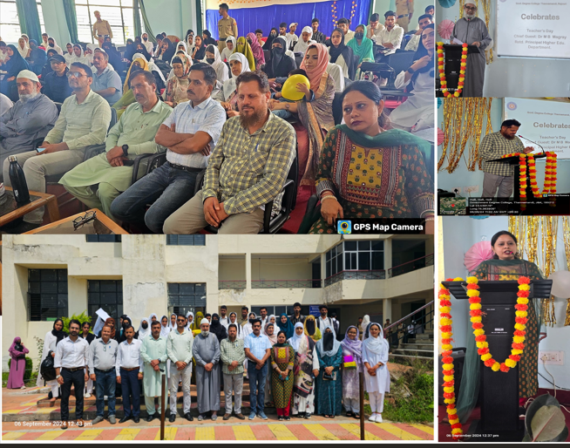

- SVEEP Awareness Program
Thannamandi, September 10th, 2024: As part of the Systematic Voters' Education and Electoral Participation (SVEEP) initiative, an awareness program was organized at Government Degree College Thannamandi organized by the District Election Office in collaboration with the Electoral Literacy Club of the College and NSS Unit. The training was imparted by Sr. Lecturer Mr Altaf Javed Dar, District Level Master Trainer and Mohd Yassir, ALMT. The program, attended by a number of students, aimed to familiarize the youth with the electoral process and encourage them to participate in the democratic process. A demonstration on EVM handling and usage was conducted, followed by a question-and-answer session. 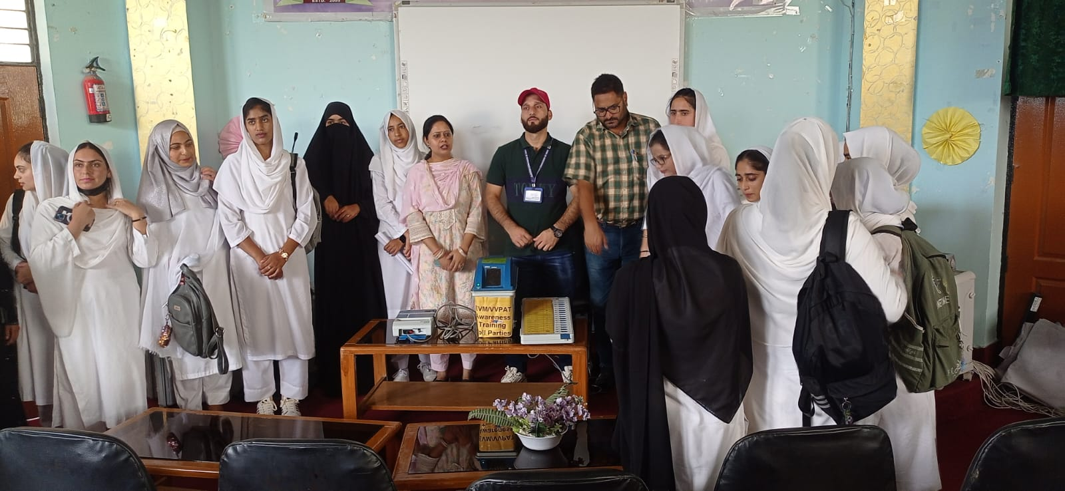
- Door-to-Door Awareness on SVEEP
Thannamandi, September 13, 2024: The Electoral Literacy Club of Govt. Degree College Thannamandi in collaboration with the NSS Unit of the college under the guidance of Principal Prof. Dr. Farooq Ahmed, organized a door-to-door awareness campaign on Systematic Voters' Education and Electoral Participation (SVEEP) in the vicinity of the college campus. Led by Nodal Officer Prof. Supriya Gupta, the students visited households to educate residents about the importance of voting, electoral processes, and the significance of participating in the democratic process. The campaign aimed to bridge the gap between citizens and the electoral process, ensuring that every eligible voter exercises their right to vote. The students engaged with residents, addressing queries and distributing informative materials to promote electoral literacy. Plantation Drive: Ek Ped Maa ke Naam

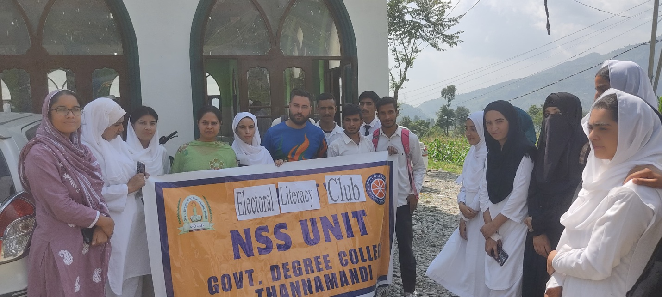

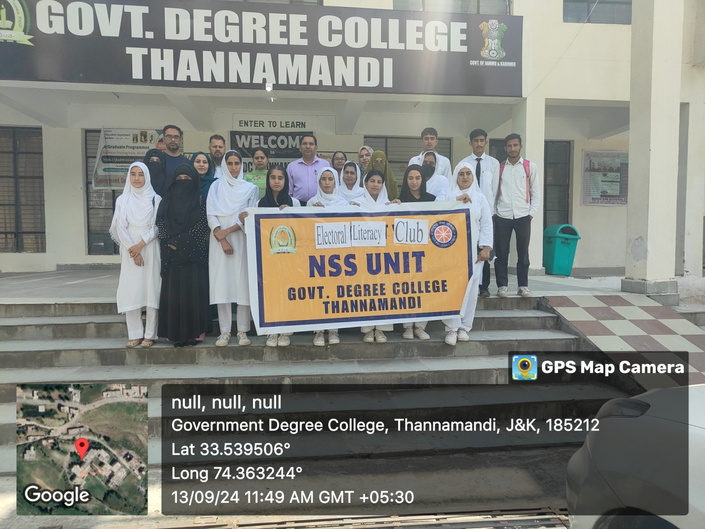
- Screening of Documentary on Mahatma Gandhi

Thannamandi, September 27, 2024 Government Degree College Thannamandi organized a special screening of a documentary on the life and philosophy of Mahatma Gandhi, under the guidance of Principal Dr. Farooq Ahmed. The event was organized by the NSS Unit in collaboration with the Culture Club is one of the series of events being organized in the campus in connection with the celebrations of Gandhi Jayanti. Attended by faculty members and students the program was aimed to commemorate Gandhi Jayanti and promote values of non-violence, peace, and social justice. The documentary explored Gandhi's remarkable journey, highlighting his philosophies, struggles, and achievements that shaped India's independence movement.
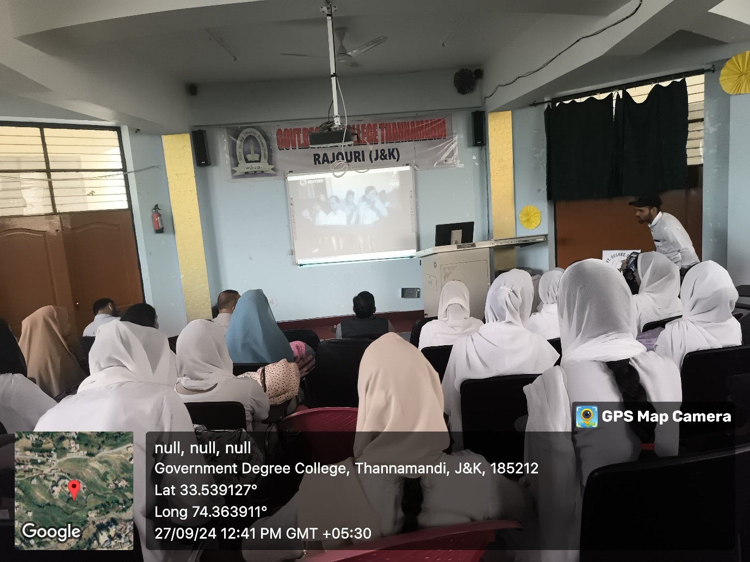
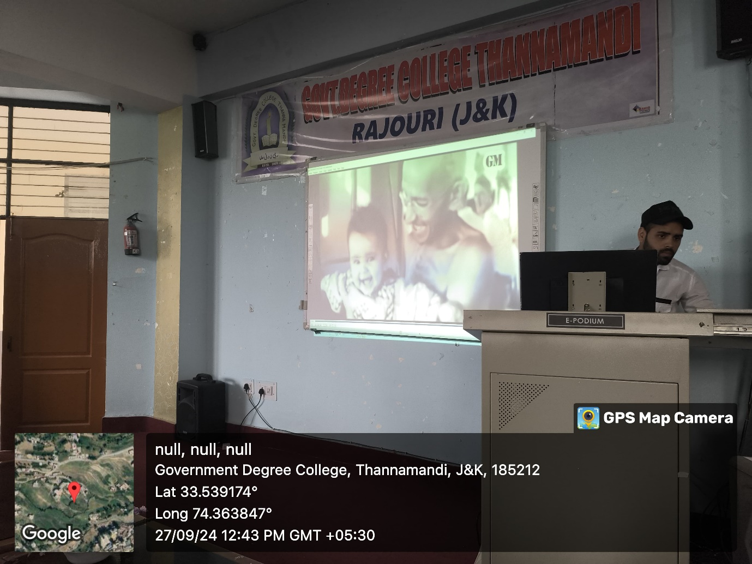

. Successfully onboarded on mybharat portal as knowledge institution
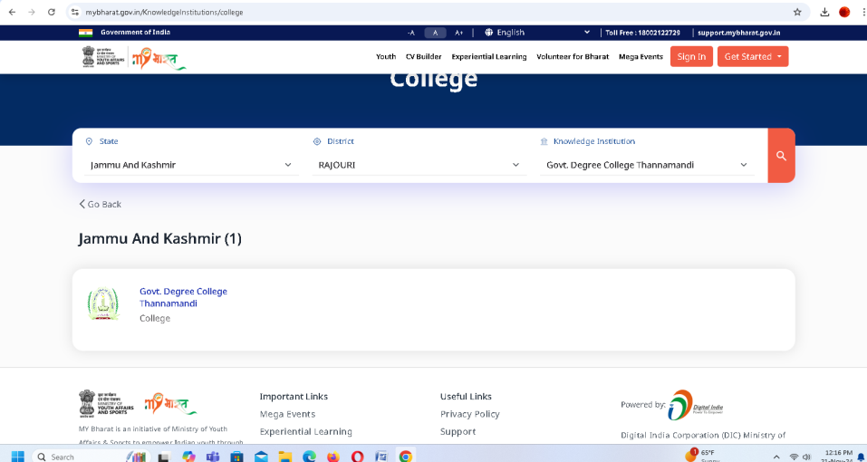

- Online Quiz on the life and Philosophy of Mahatma Gandhi
Thannamandi, October 01, 2024: Commemorating the 153rd birth anniversary of Mahatma Gandhi, the National Service Scheme (NSS) unit of Government Degree College (GDC) Thannamandi organized an online quiz on the life and philosophy of the Father of the Nation, under the guidance of Principal Dr. Farooq Ahmed. The event was organized by the NSS Unit in collaboration with the Culture Club is one of the series of events being organized in the campus in connection with the celebrations of Gandhi Jayanti. The quiz aimed to educate participants about Gandhiji's principles and values and inspire youth to embody his teachings, covered aspects of Gandhiji's life, philosophy, and contributions, including: early life and education, Non-cooperation movement, Quit India movement, Philosophy of non-violence and satyagraha. Students from various colleges and institutions across the district participated and those who qualified got certificates.
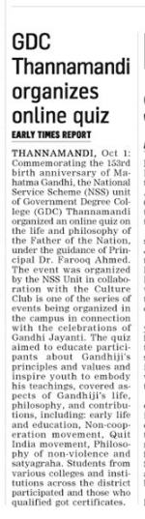
Cleanliness Drive
Cleanliness drive was organized in the College campus by NSS Unit of the College under the proficient guidance of Principal of the College Prof Dr Farooq Ahmed. A total number of 22 volunteers, along with NSS Programme Officer Professor Supriya Gupta and faculty of the college participated in the drive. Students and faculty members cleaned and dusted classrooms, including furniture, smart boards, and windows. Laboratory equipment, tables, and floors of different departments were thoroughly cleaned and disinfected. Recyclable and non-recyclable waste was segregated and disposed of properly. Also, students were educated on the importance of maintaining cleanliness and hygiene.
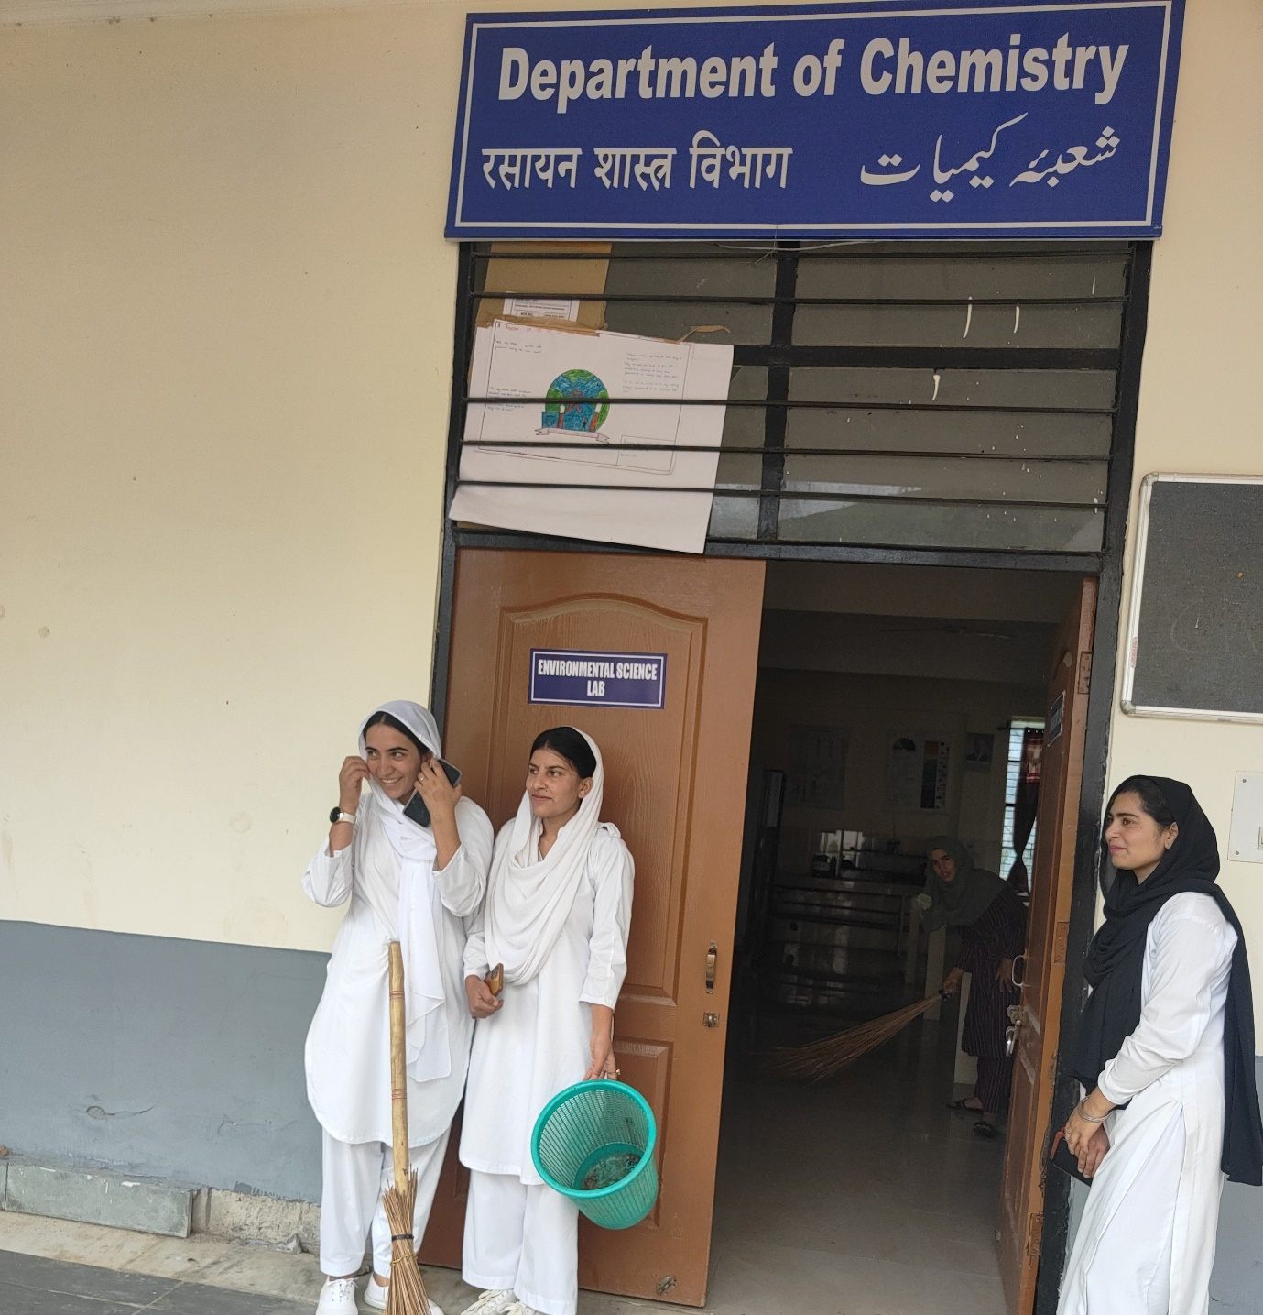
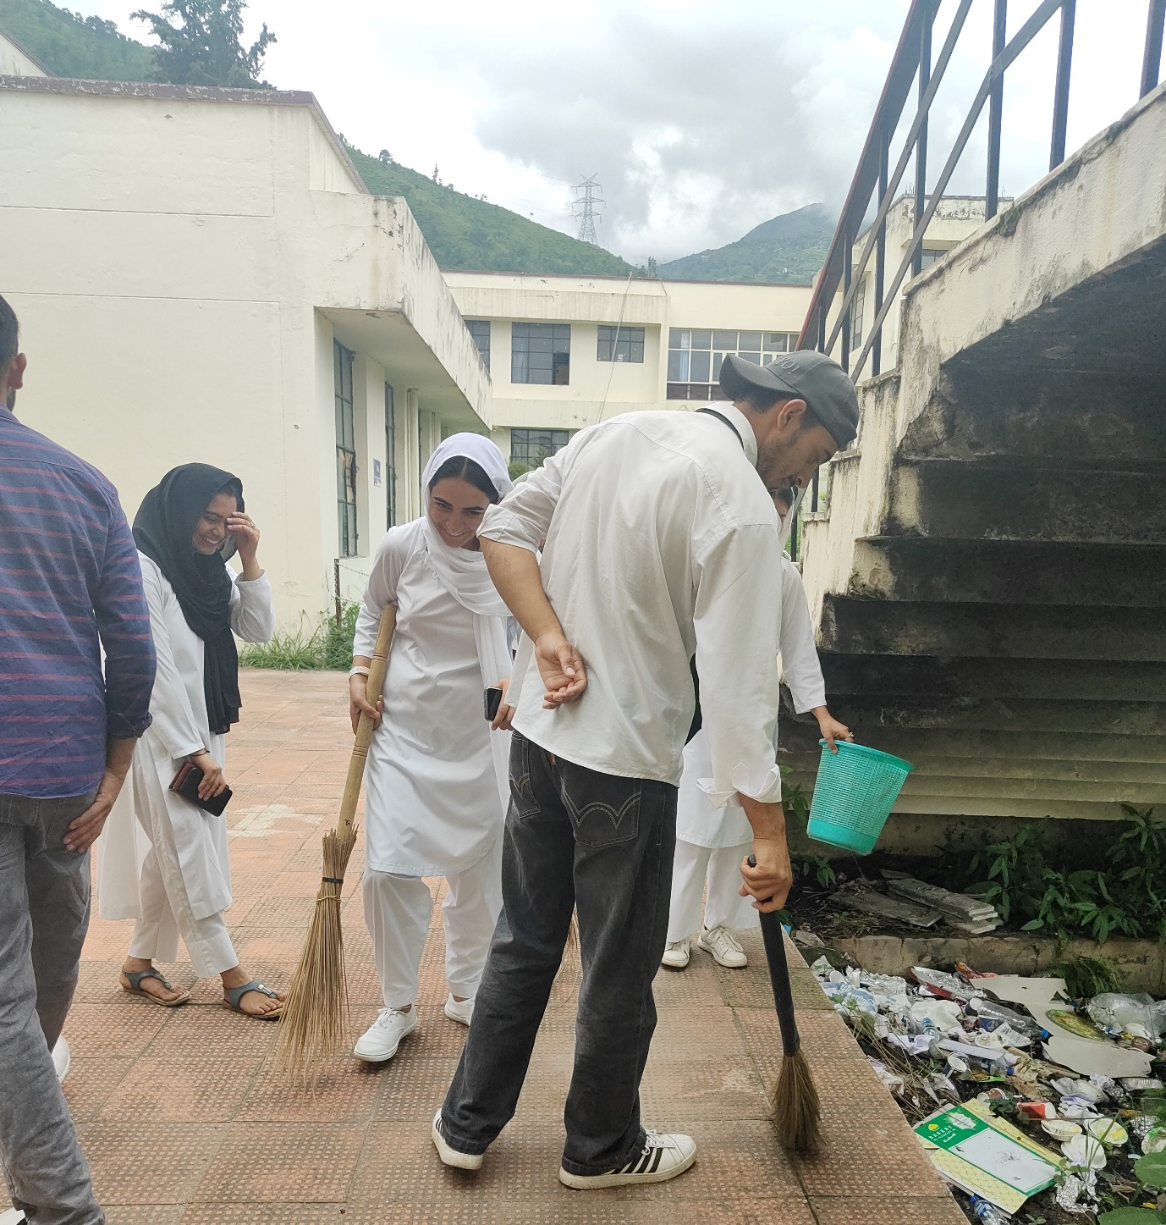
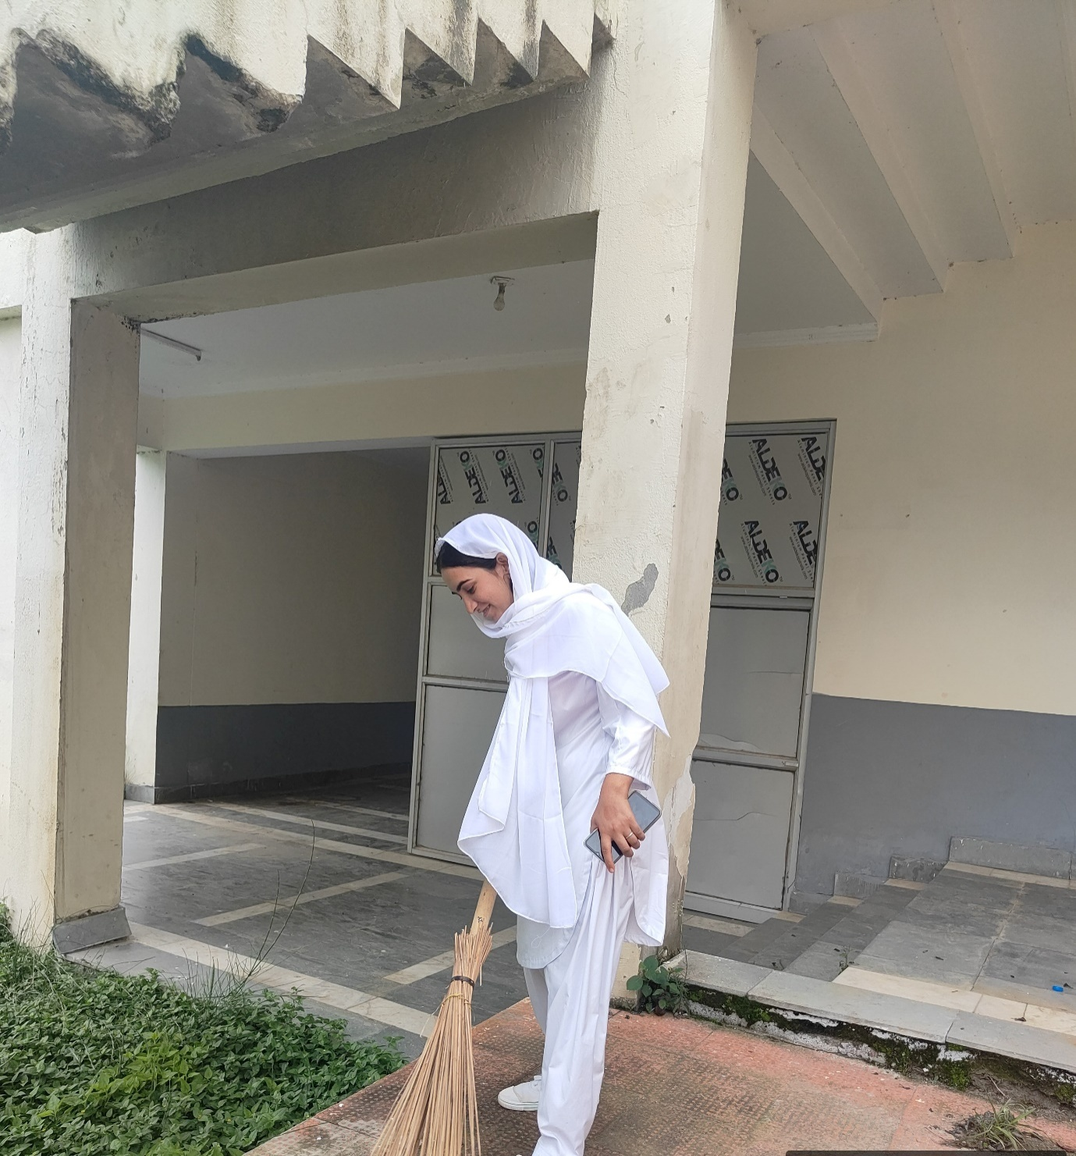

- Unity Pledge and Essay Competition on National Unity Day
Thannamandi, Rajouri October 30: Government Degree College Thannamandi commemorated National Unity Day, a day celebrated nationwide in honor of Sardar Vallabhbhai Patel, the “Iron Man of India” who played a pivotal role in unifying the country. The event commenced with a Unity Pledge, where the entire college community, including faculty members, administrative staff, and students, collectively reaffirmed their commitment to national unity and integrity. As part of the observance, the NSS Unit of GDC Thannamandi organized an essay writing competition on the theme “The Role of Sardar Patel in Unifying India.” Students enthusiastically participated, showcasing their understanding of Patel’s visionary leadership and his efforts to integrate the princely states into a unified India. The competition provided students an opportunity to delve into Patel’s contribution to India’s history and reflect on its relevance in contemporary society. Principal Prof. Dr. Farooq Ahmed lauded the efforts of the NSS Unit for their initiative, encouraging the students to carry forward the values of unity, integrity, and patriotism demonstrated by Sardar Patel. The winners of the essay competition were awarded with certificates.
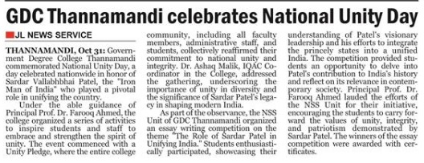

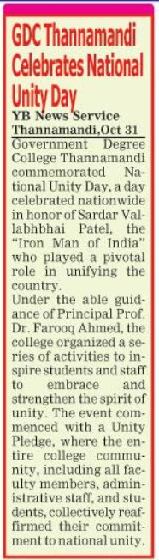

- Intra-College seminar cum poster making competition: An intra-College Seminar and a Poster making Competition organized on the theme “Culture of Integrity for Nation’s Prosperity” under the patronage of Prof. (Dr.) Farooq Ahmed, Principal of College in which Bagh Hussain, Tehsil Treasury Officer Thannamandi was special Guest. Dr. Ashaq Malik, IQAC Co-ordinator and Dr. Gulshan Rashid Bhat, Head, Department of Geography in College co-ordinated the program. Kamran Mumtaz of B.Sc 5th Sem stood first whereas Laiba Fatima and Ateeqa Fatima of B.A 1st Sem bagged 2nd and 3rd position in the seminar respectively. Dr. Nazar Ul Islam, Head, Department of Islamic Studies, Dr. Junaid Ahmed, Head, Department of Environmental Sciences and Prof. Rumy Dar, Head, Department of English in College were judges in the intra-college seminar. In the poster making competition, Alia Fatima, B.A 3rd Sem., and Irtaqa Naik and Sultana Kouser, B. Sc 3rd Sem. shared first prize whereas Sanam Kouser, B. Sc 3rd sem, and Uzma Maqsood, B.Sc 5th, won 2nd Prize. Kehkashan Rozeen of B.Sc 5th sem & Sabha Shaheen of BA 5th Sem bagged 3rd prize in the poster making competition that was coordinated by Prof. Rumy Dar and Dr. Nagina Kouser
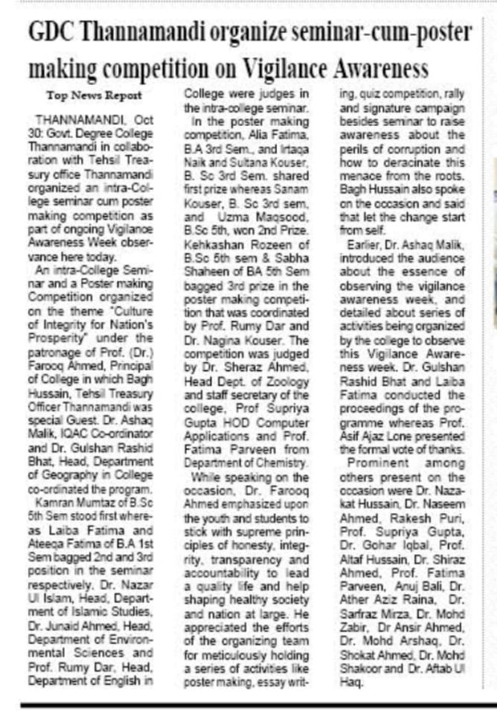

Govt. Degree College Thannamandi Organizes Awareness Program on Sanitary Pad Vending Machine Usage and Hygiene for Girl Students
Thannamandi Nov 12, 2024– In an important initiative to promote menstrual health and hygiene among young girls, the Women Development Cell (WDC), in collaboration with the NSS Unit of GDC Thannamandi, under the guidance of the principal Prof Dr. Farooq Ahmed, organized an awareness program under the banner of Beti Padhao, Beti Bachao. The program aimed to educate female students on the use of sanitary pad vending machines and emphasize the importance of personal hygiene.
The event, held at Girls Common Room, was attended by Prof. Fatima Parveen, Convener of the Women Development Cell, alongside Prof. Rumi Dar, Prof. Rizwana Kouser, Prof. Nagina Kouser, and Ms. Sugra Jabeen, members of the WDC. Prof. Supriya Gupta, NSS Program Officer, also played an active role in coordinating the program.
During the session, the students were provided a live demonstration of the sanitary pad vending machine, explaining its use, convenience, and accessibility. In addition to hands-on guidance, the program addressed critical aspects of menstrual hygiene, aiming to dispel myths, reduce stigma, and empower young girls to make informed choices about their health and well-being.
Speaking at the event, Prof. Fatima Parveen highlighted the importance of hygiene awareness, stating, "Our goal is to create a supportive environment where young girls feel empowered to prioritize their health. Through initiatives like this, we hope to foster a sense of confidence and promote awareness on crucial topics like menstrual hygiene."
Prof. Supriya Gupta added, "The collaboration between the Women Development Cell and the NSS Unit under the Beti Padhao, Beti Bachao campaign is a step towards ensuring that every young girl has access to essential resources and information. We aim to make menstrual health a comfortable topic to discuss openly."The program received positive feedback from participants, who expressed a newfound understanding of menstrual hygiene and appreciation for the accessible solutions provided. 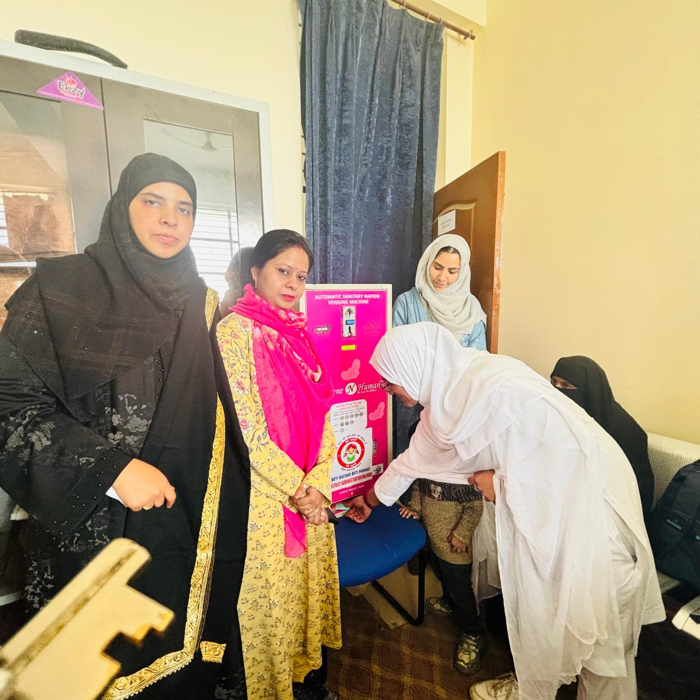
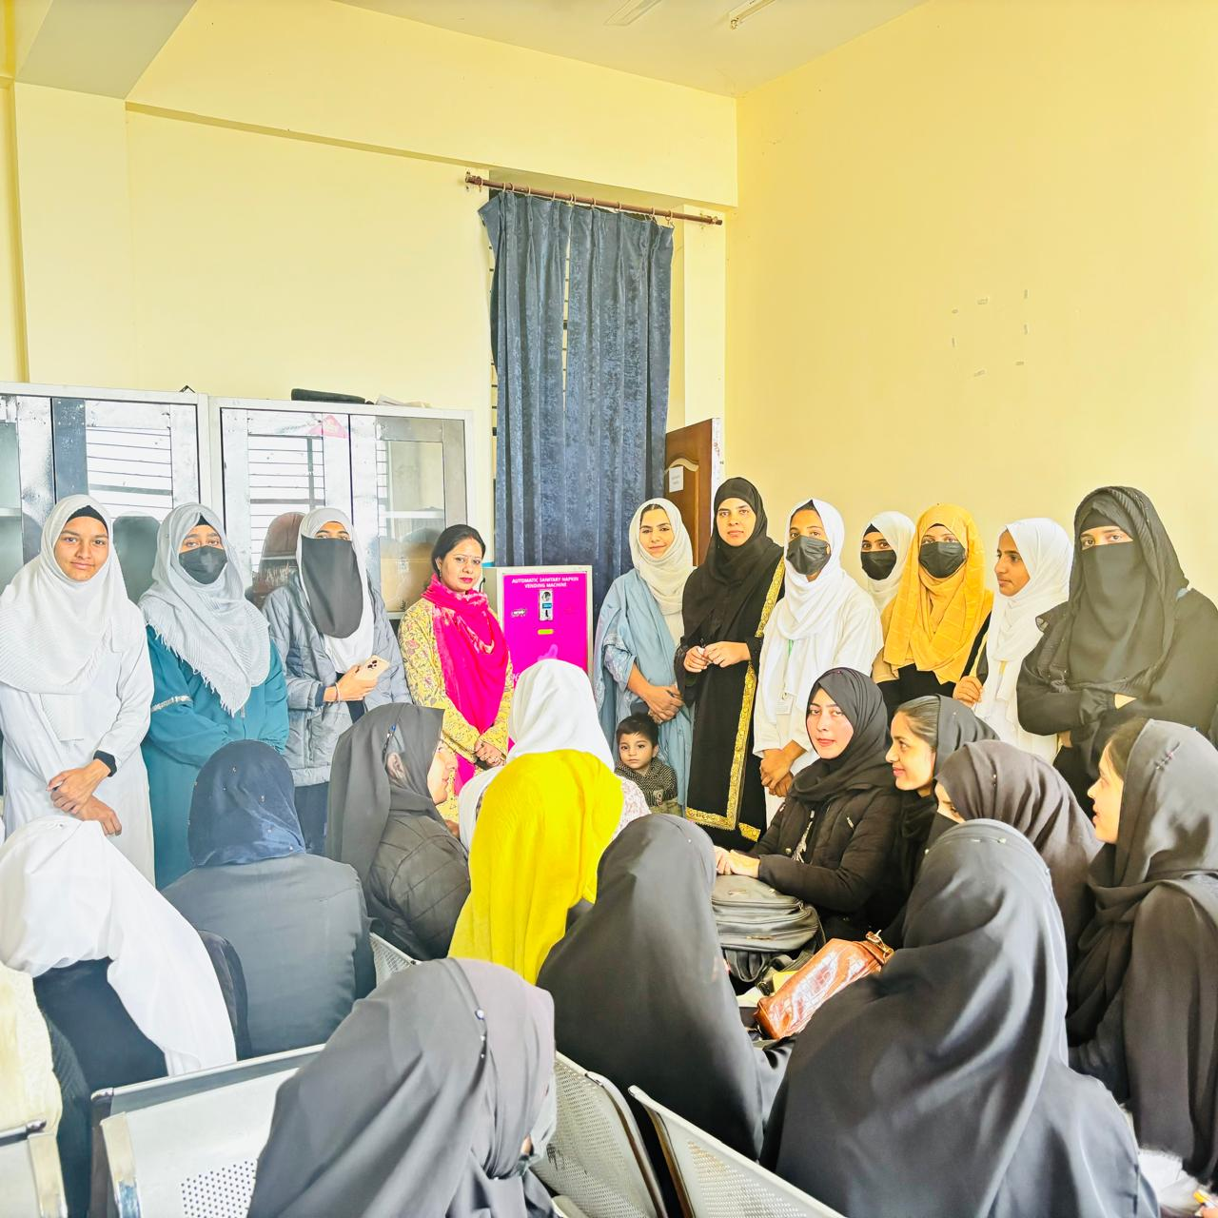
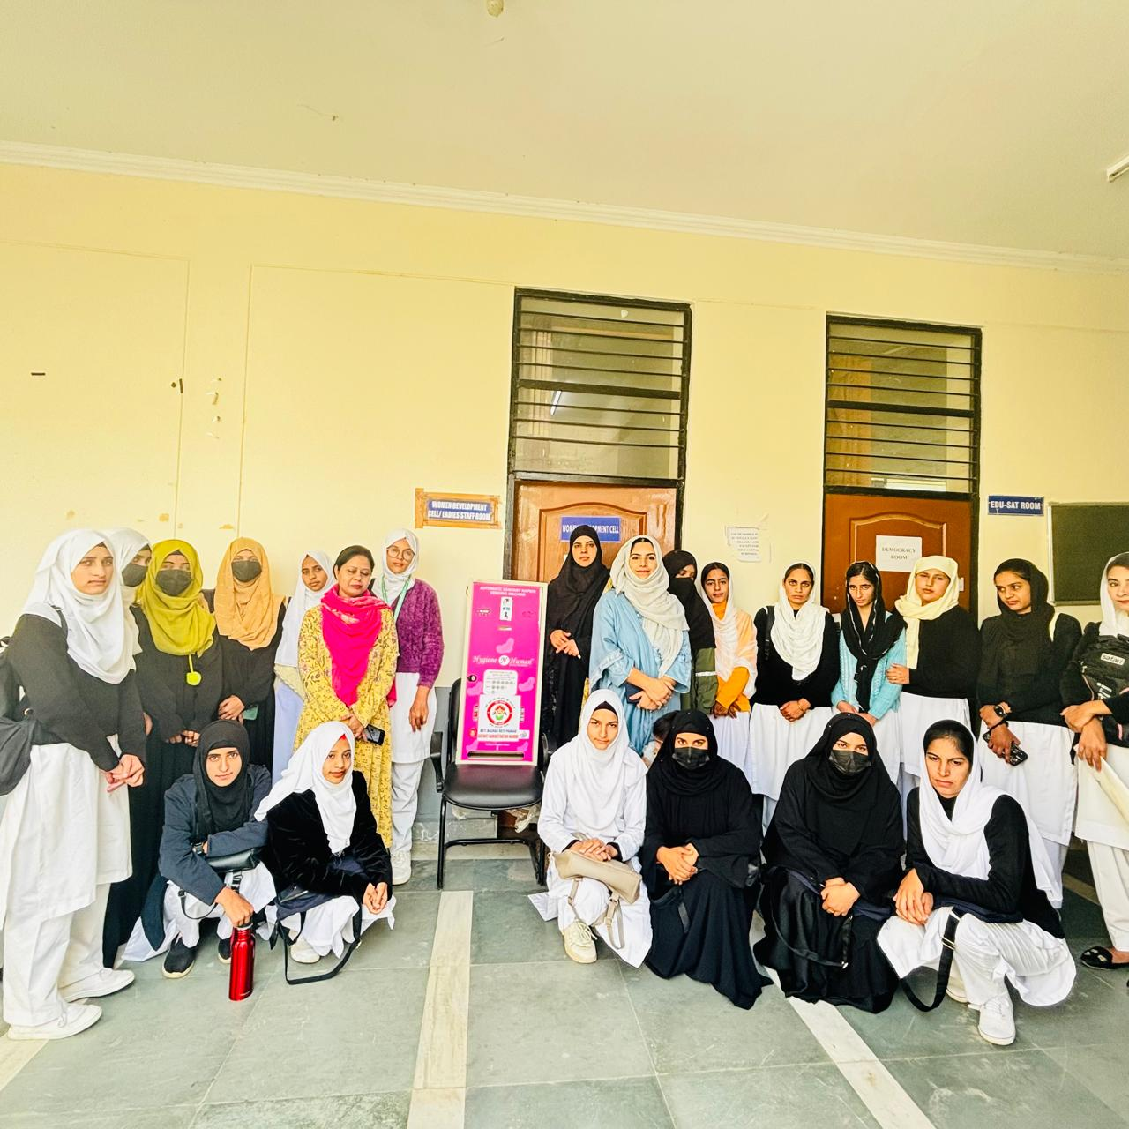
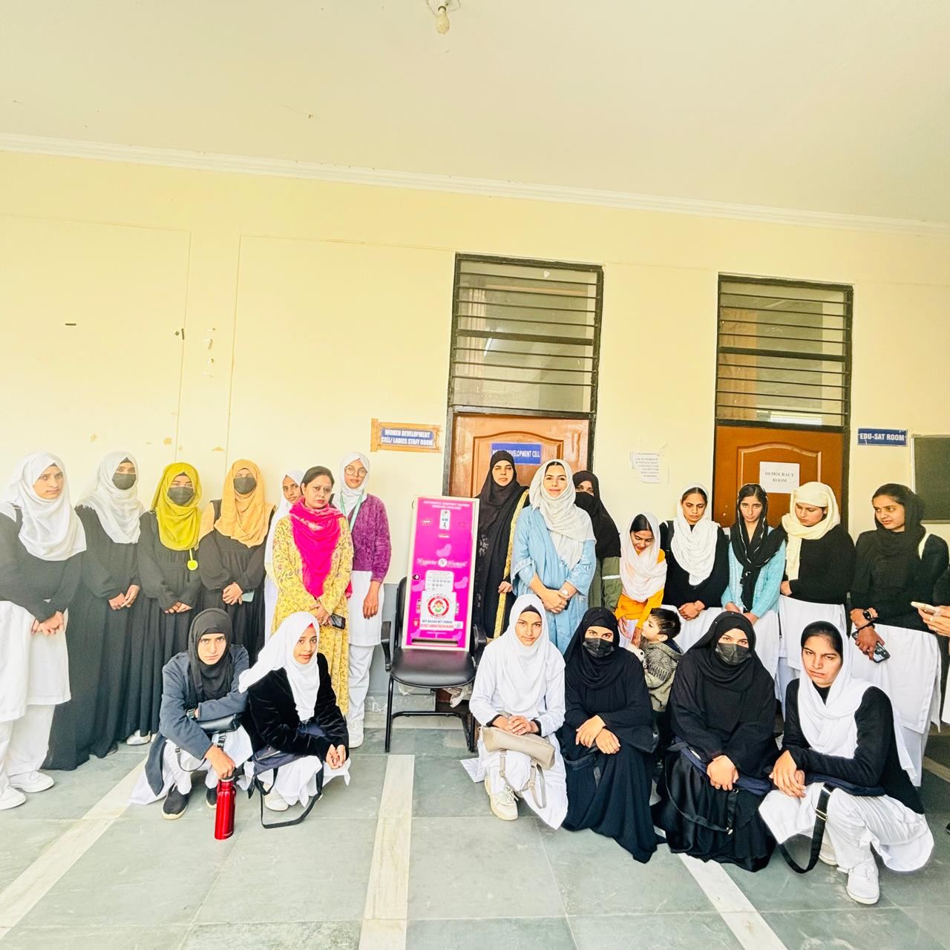
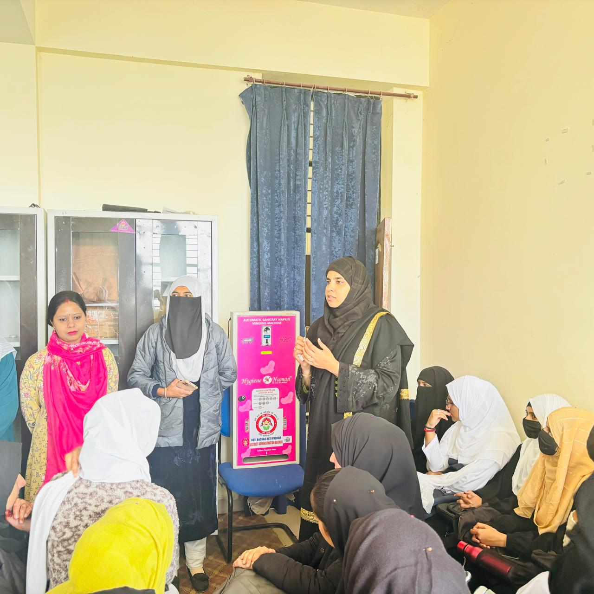

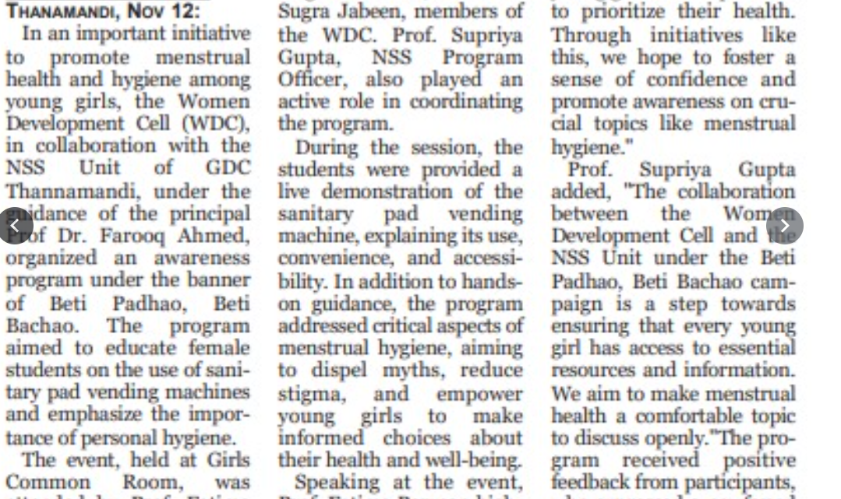
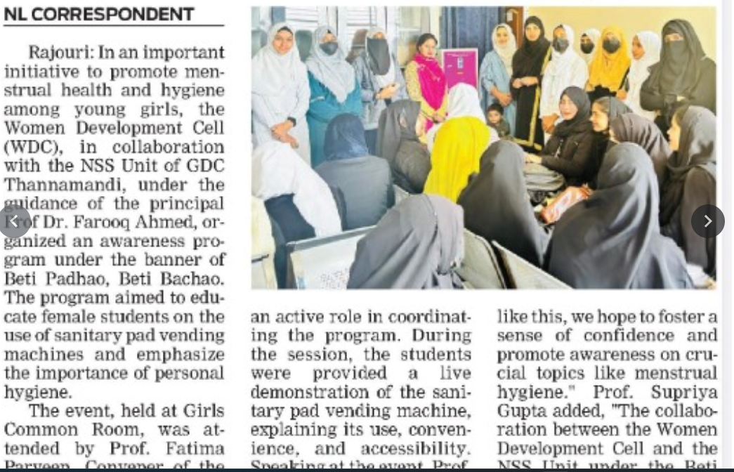

Cleanliness Drive in college campus:

Observance of World AIDS Day in GDC Thanamandi

Red Ribbon Club of GDC Thanamandi in collaboration with the NCC and NSS Unit of the college organised a program on Monday, 2nd of Dec. 2024 to observe the World AIDS Day on the theme “TAKE THE RIGHTS PATH”. The program was presided over by Principal of the College Prof. (Dr.) Farooq Ahmed. In his presidential address, he discussed in detail about the basics of immune deficiency and how CD4 Cells affected by the HIV Virus. In his comprehensive discussion he also suggested measures on how to stay away from this dreaded disease. Dr. Farooq Ahmed discussed the significance of the day and showed how people around the world unite to express support for people living with and affected by HIV and to remember those who lost their lives to AIDS. How the world can end AIDS, with communities leading the way.
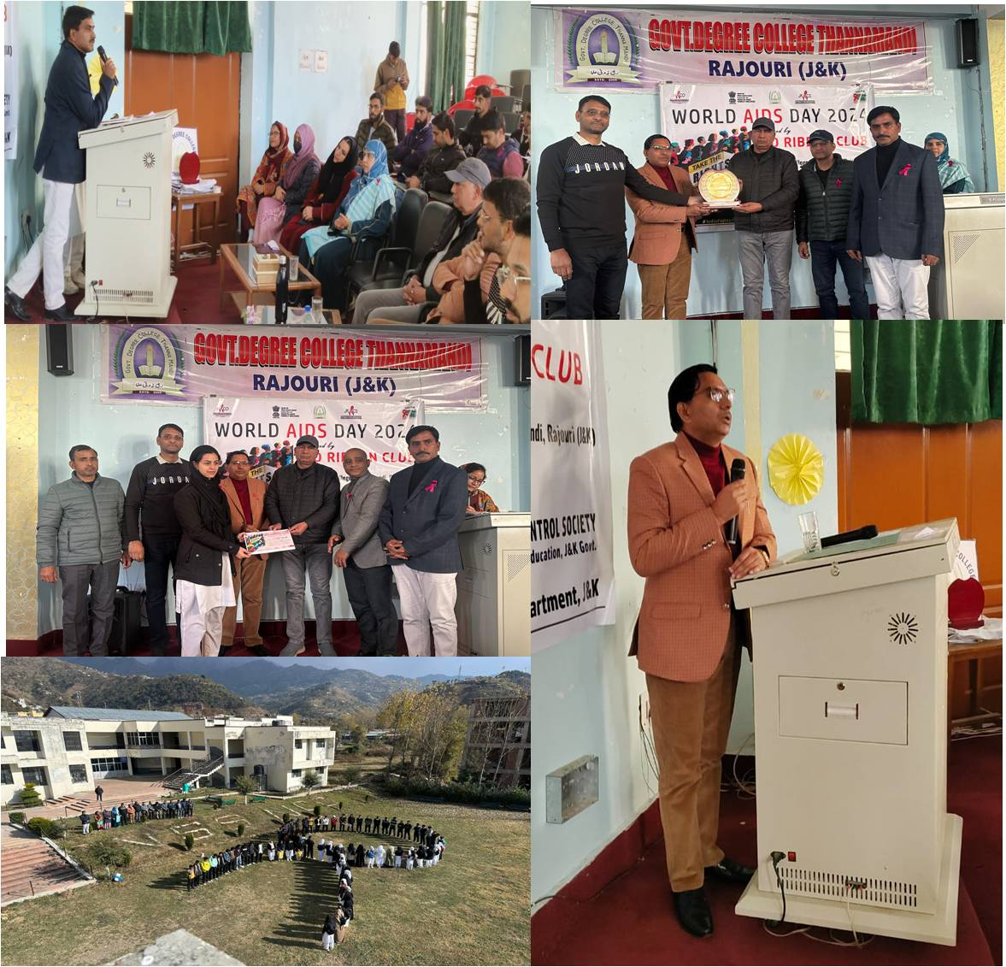

On this ocassion Dr. Ghulam Ahmed (Medical officer) was the chief guest who delivered a special lecture on AIDS, its occurrence, causes, as well as preventive measure to control it. Dr. Ghulam in his lecture discussed in detail with the audience about the general causes of AIDS and how can one prevent oneself from it. His lecture was very informative and highly appreciated by the audience. An interactive question answer session was also held in which students and staff of the college raised queries about AIDS and cleared some doubts and misconceptions about the disease. On the other side as a part of the program, a poster making competitions was also organized on the theme ‘TAKE THE RIGHTS PATH’. In the poster making competition a number of students participated and made beautiful posters exhibiting various aspects of the theme vis a vis AIDS control. Ms. Laiba Fatima and Noor Fatima got first position, Ms. Zehra Fatima stood 2nd and Mr. Zia got 3rd position respectively in the poster making competition. The students were awarded with mementoes and participation certificates. The Judges during the event were Prof. Altaf Hussain HOD Education, Dr. Gulshan Rashid Bhat HOD Geography and Dr. Ather Aziz Raina HOD Mathematics. While in the symposium nine students participated in which Mr. Zia secured first position, 2nd and 3rd position secured by Ms. Liaba Fatima and Ms. Ateeqa Fatima respectively. In this session Dr. Nazar ul Islam, Prof. Fatima Parveen and Dr. Athar Aziz Raina played the role of judges, all the participants were awarded by appreciation certificates.
Dr. Shiraz Ahmed Nodal Officer Red Ribbon Club also spoke on the occasion. He presented the statistical data regarding AIDS and highlighted on how this disease is consuming the world with the passage of time. The talk was quite impressive and comprehensive. He stressed upon the audience to KNOW AIDS for NO AIDS. During the culmination of the program, a human chain was formed by students of the college to show solidarity with the people who were infected by HIV or have suffered due to AIDS.
Ms. Laiba Fatima and Ms. Ateeqa Fatima student of 1st semester of the college conducted the proceedings of the program under the guidance of Dr. Shiraz Ahmed, HOD Zoology and Nodal Officer Red Ribbon Club of the college. The programme was conducted in collaboration with NSS and NCC wing of the college. A memento and live plant was presented to chief guest Dr. Ghulam Ahmed as a token of gratitude. Prof. Fatima Parveen Presented the formal vote of thanks. Others present during the event were Dr. Nazakat Hussain, Dr. Naseem Ahmed, Prof. Abdul Haq Naimi, Dr. Nazar ul Islam, Prof. Junaid Ahmed, Dr. Gohar Iqbal, Prof. Rumy Dar, Dr. Athar Aziz Raina, Prof. Rizwana Kouser, Dr. Nagina Kouser, Dr. Arshaq Ahmed, Dr. Sajid Ali, Mr. Anuj Bali, Mr. Rakesh Puri Dr.Showket Ahmed Dar, Dr. Ateeq, Dr. Shakoor and Dr. Zubair Ahmed. At the end of the programme refreshment was served to all participants.

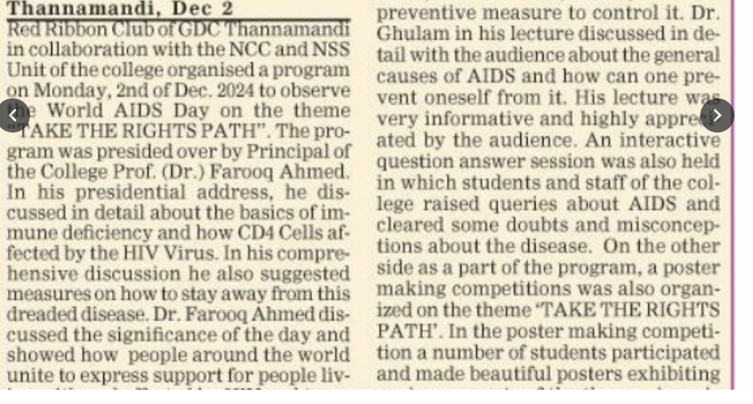 Principal
GDC Thannamandi

NSS Seven-Day Special Winter Camp
Introduction: The 7-day Special National Service Scheme (NSS) camp at Government Degree College (GDC) Thannamandi was conducted with the objective of fostering community engagement,
environmental awareness, and promoting cleanliness. The camp took place under the guidance of the Principal, Dr. Farooq Ahmed, and was organized by Program Officer, Supriya Gupta. Throughout
the week, NSS volunteers participated in various activities aimed at enhancing the aesthetic appeal of the campus, spreading awareness on environmental issues, and contributing to community development.
Duration:
The camp was held from Jan 8-16,2025 spanning 7 days, with active participation from NSSvolunteers, faculty members, and local residents.
No. of Volunteers participated: 30
Activities Undertaken During the Camp
Day-1:Inauguration A 7-day NSS Special Winter Camp started at Government Degree College Thannamandi, amidst great enthusiasm and fervour under the guidance of Principal Dr. Farooq Ahmed. The inauguration ceremony was graced by the presence of esteemed guests, including Dr. Ashaq Malik, Coordinator IQAC, Anuj Bali, Chief Librarian, and NSS PO Prof. Supriya Gupta. The camp, which will run for seven days, aims to foster community service, social awareness, and personality development
among the volunteers. 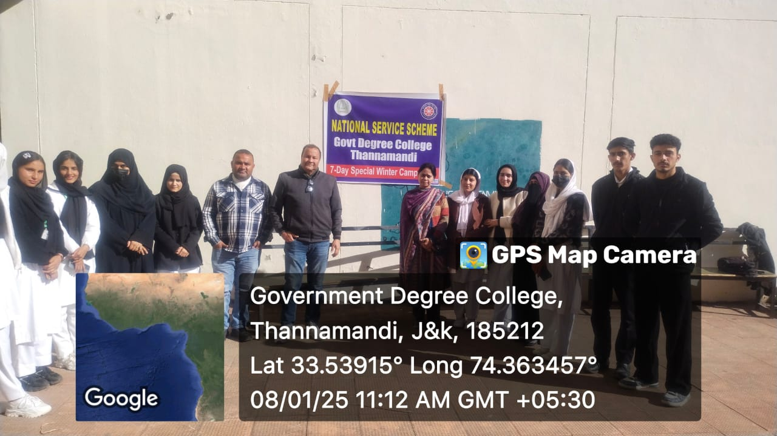

Inauguration: Dr. Ashaq Malik, Coordinator IQAC, highlighted the significance of volunteer’s ship in shaping individuals and society. His inspiring words
motivated the volunteers to dedicate themselves to the cause and make the most of the camp activities. Prof. Supriya Gupta encouraged the volunteers to actively participate in community service and make a positive impact on society.
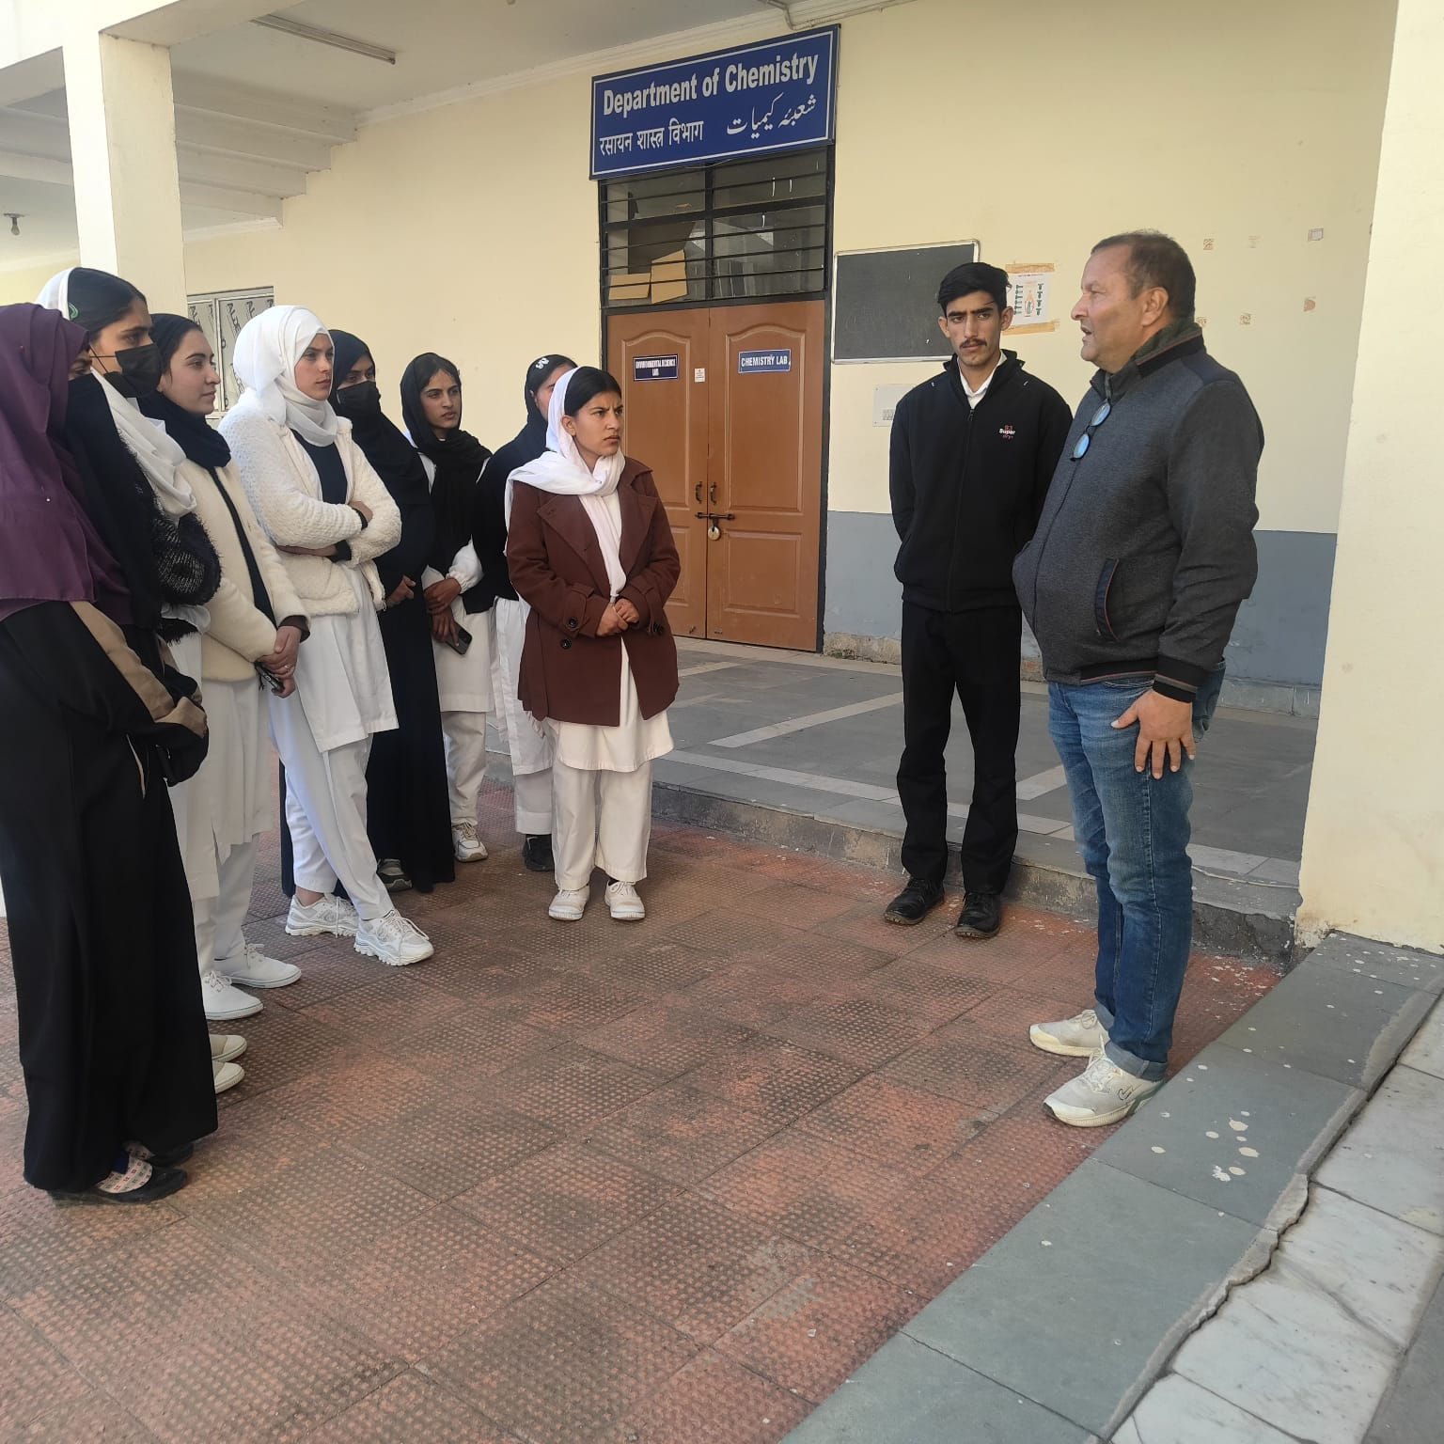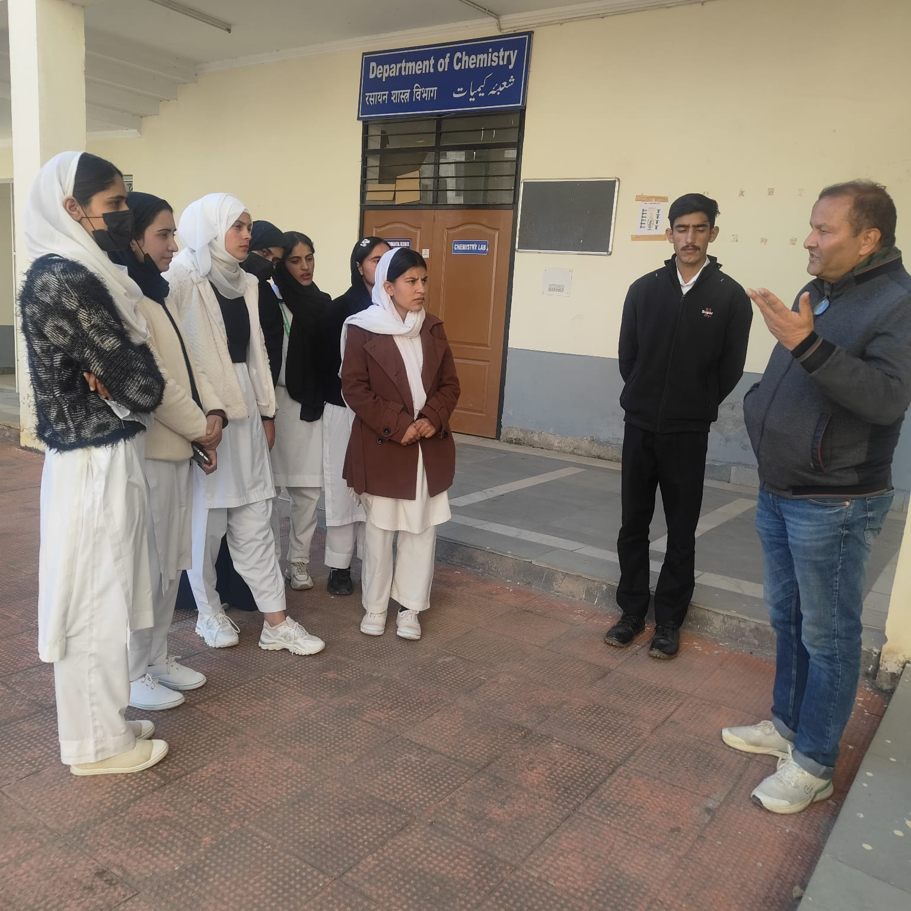
- Campus Beautification and Cleanliness Drives: Volunteers thoroughly cleaned the entire college campus, focusing on areas that required special attention. Tasks included sweeping, waste disposal, and removing debris from various parts of the campus. They worked tirelessly to maintain a clean and hygienic environment in and around the college.
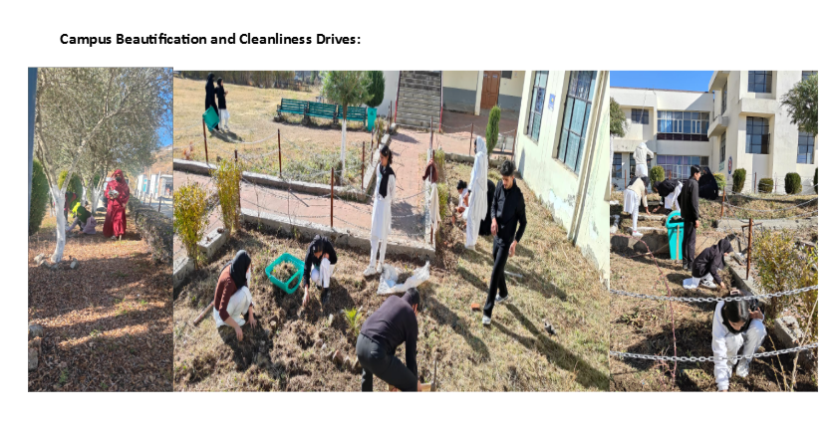
- Flower Beds on Waste Land: As part of the beautification drive, the volunteers converted barren and waste land into visually appealing spaces by creating flower beds. This initiative not only enhanced the beauty of the campus but also contributed to the overall environmental sustainability of the college.
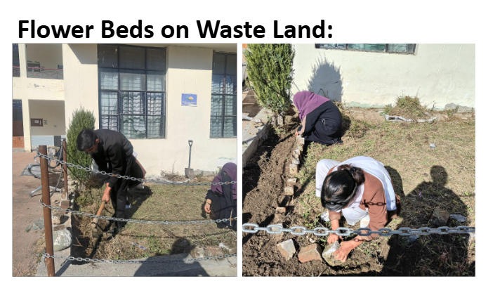
- Whitewashing and General Beautification Tasks: The volunteers carried out extensive whitewashing of the walls, ensuring that the college premises appeared fresh and well-maintained. This activity covered various sections of the campus, including classrooms, corridors, and the main administrative block.
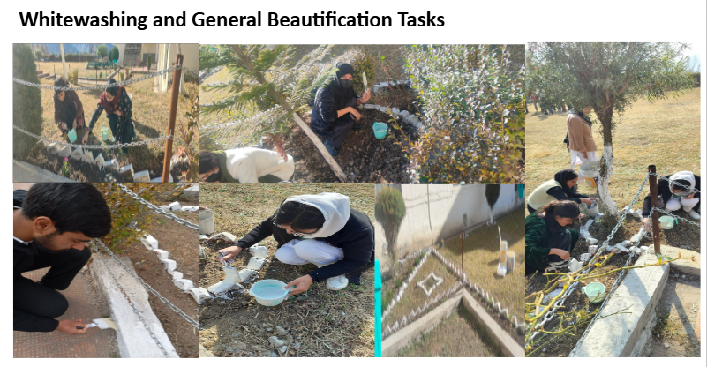
- Main Gate, Lawns, and Grounds Enhancement: The main gate area, lawns, and grounds were cleaned and improved to create a welcoming environment for both students and visitors. The volunteers cleared overgrown grass, planted new shrubs, and tidied up the surroundings to make the campus more aesthetically pleasing.
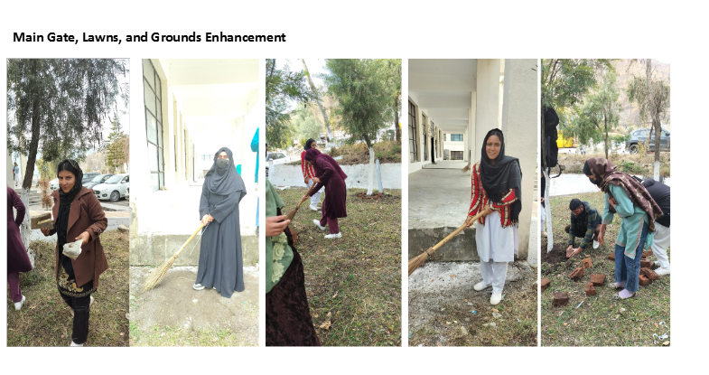
- Outreach Activity – Cleaning of LaaBawli: On a community level, the volunteers carried out an outreach activity by cleaning the renowned natural water resource, LaaBawli, located in the village of Khablan. This activity was aimed at promoting awareness about water conservation and the importance of keeping natural resources clean. Volunteers cleared the surrounding area, removed waste, and ensured the area was left clean for continued use by the villagers.
- 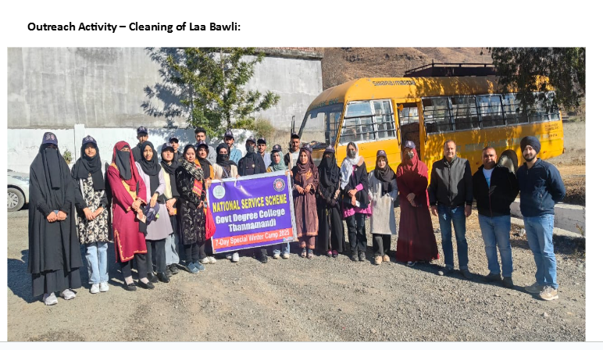
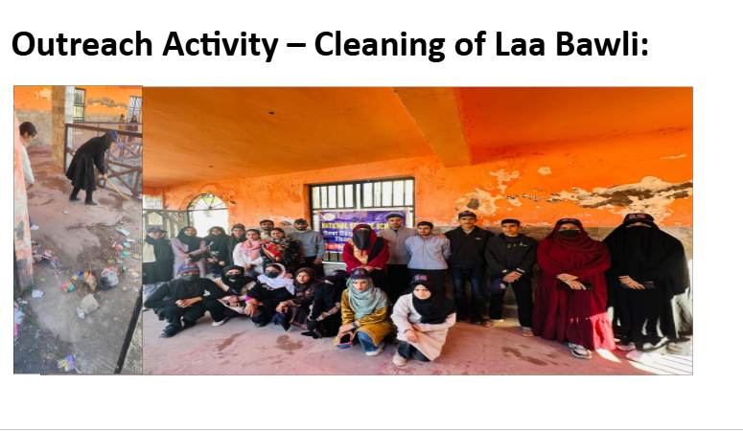
- Awareness Campaign at Middle School, Law: A group of volunteers visited the Middle School in Law village to conduct an awareness session for students and staff on cleanliness, pollution, and other health-related issues. The session included discussions on maintaining personal hygiene, reducing plastic usage, waste management, and the importance of pollution-free surroundings for overall health. 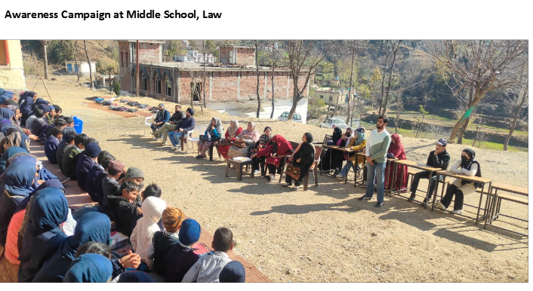

Valedictory
Function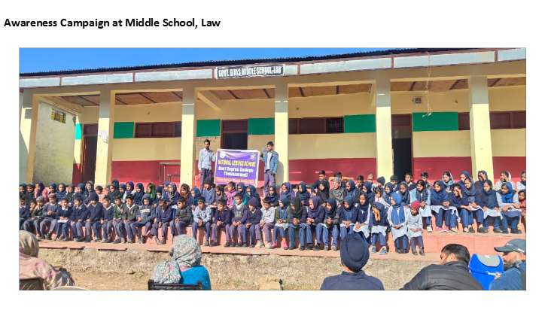
Outcome and Impact:
- The college campus was transformed into a cleaner and more aesthetically pleasing environment through the combined efforts of the NSS volunteers.
- The creation of flower beds on waste land not only beautified the campus but also contributed to the sustainability of the area by promoting green spaces.
- Whitewashing and general cleanliness efforts greatly enhanced the overall look of the college, making it more welcoming for students and faculty.
- The outreach activities, including cleaning LaaBawli and raising awareness at the Middle School in Law, helped foster a sense of responsibility among local residents and students regarding environmental conservation and health practices.
- The camp encouraged a spirit of teamwork, community service, and environmental stewardship among NSS volunteers.

- 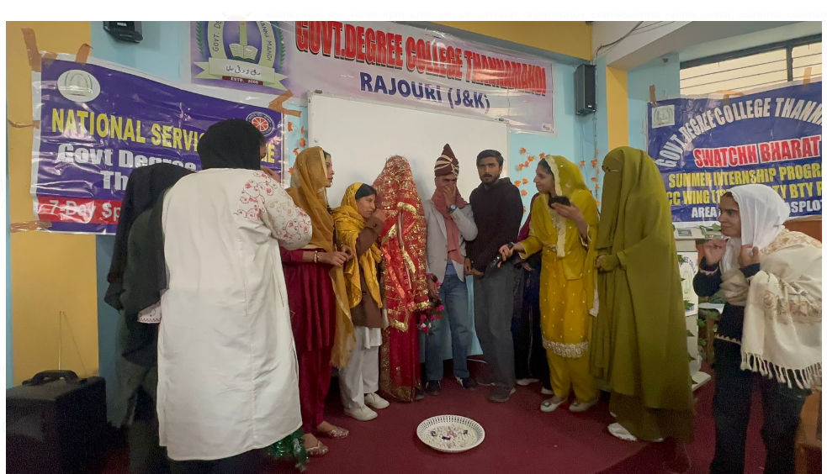

- 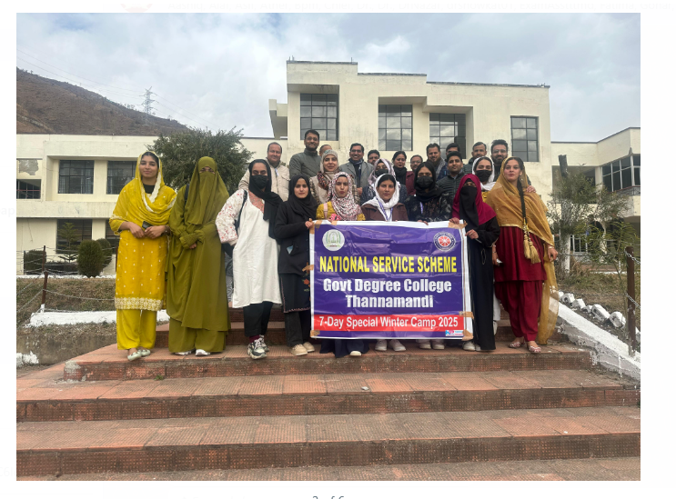
- Plantation drive

GDC Thannamandi initiates Republic Day celebrations by Plantation Drive

Thannamandi, January 21: Government Degree College Thannamandi initiated the Republic Day Celebrations with a plantation drive organized by Department of Botany in collaboration with the College Beautification Committee and the National Service Scheme (NSS) Unit as part of Viksit Bharat @2047 Abhiyan here today. A daylong plantation drive organized under the patronage of Prof. (Dr.) Farooq Ahmed, Principal of the College. Tehsildar Thannamandi Syed Mazhar Ali Shah and Naib-Tehsildar Thannamandi Mehmood Azam were special guests on this
occasion. Dr. Ashaq Malik, Head, Department of Botany, Prof. Fatima Parveen Convener, Campus Beautification Committee and Prof. Supriya Gupta, NSS PO at GDC Thannamandi co-ordinated
the drive wherein students of Botany Department along with NSS Volunteers were involved in raising beds and plantation of seasonal plants.
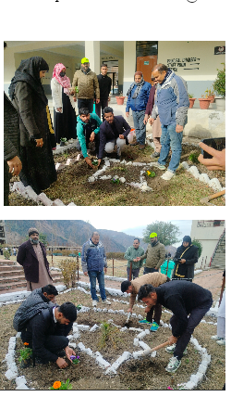
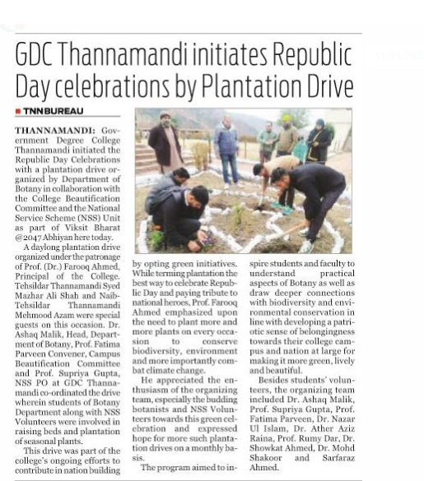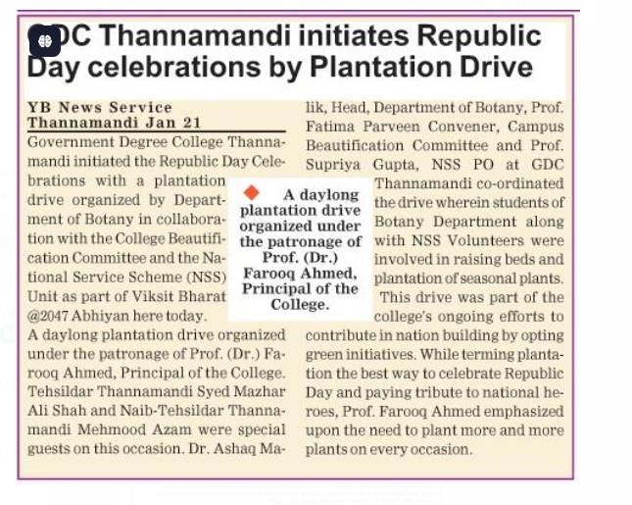

Government Degree College Thannamandi Organizes Road Safety Awareness Program
Thannamandi, January 22: A successful road safety awareness program was conducted by the NSS Unit of Government Degree College Thannamandi, under the guidance of Principal Dr. Farooq Ahmed. The program conducted as part of series of events organized under National Road Safety Month, included a rally where volunteers raised slogans on safety rules and interacted with drivers on the road, educating them about the consequences of breaching safety rules. Prof. Supriya Gupta, the NSS Program Officer, played a key role in organizing the event, which aimed to promote road safety awareness among the general public. The volunteers' efforts were instrumental in spreading awareness about the importance of following traffic rules and regulations.
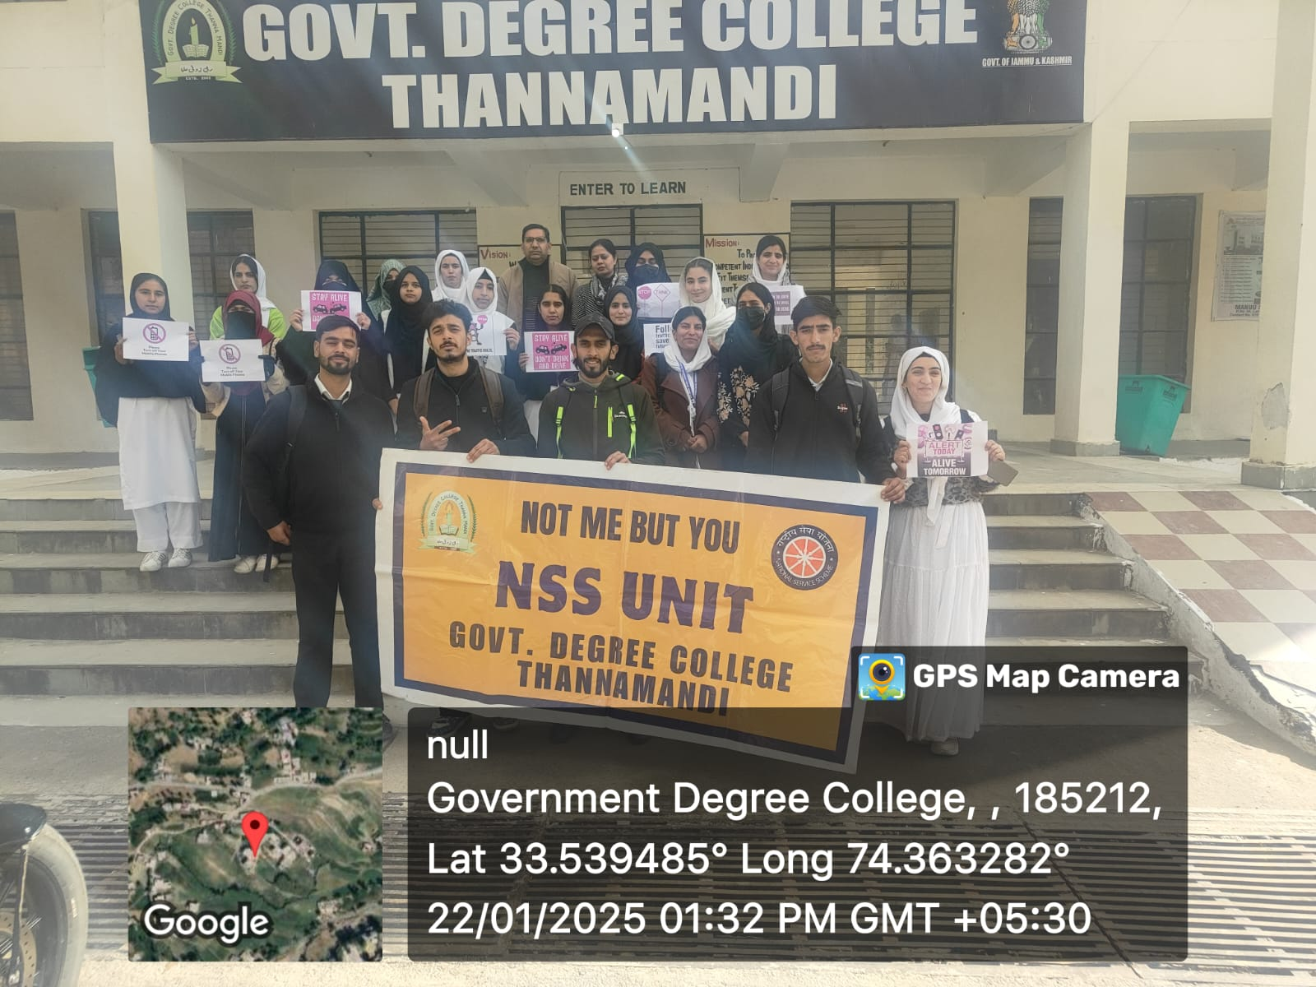
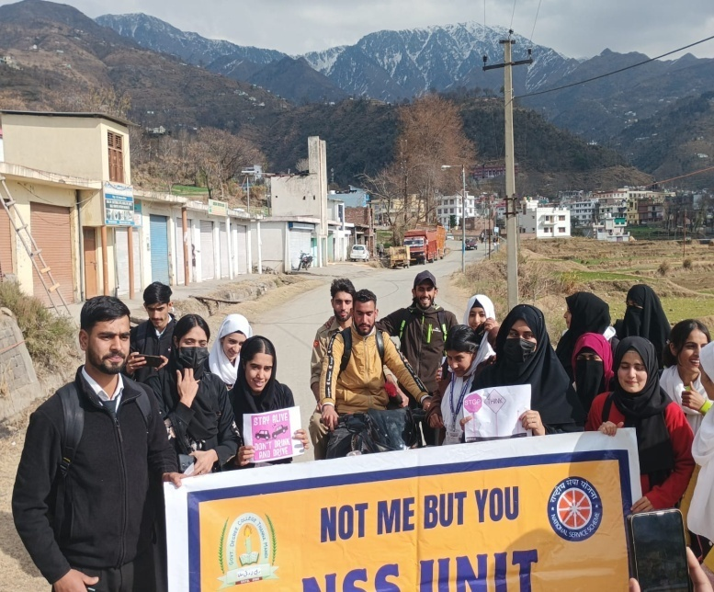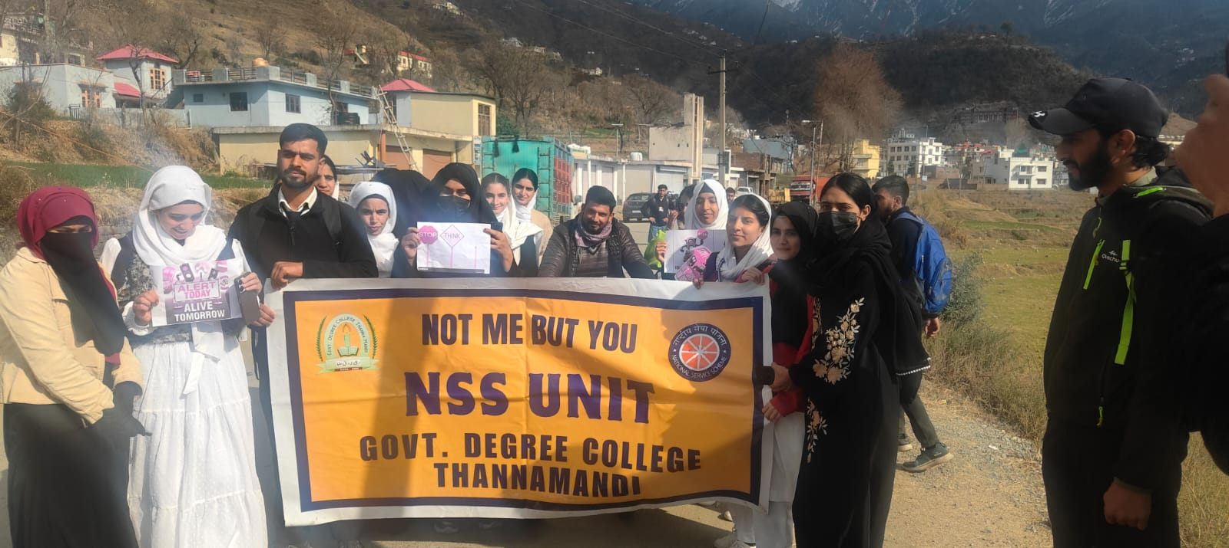
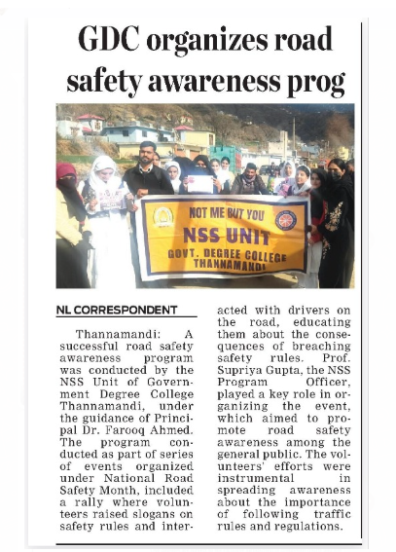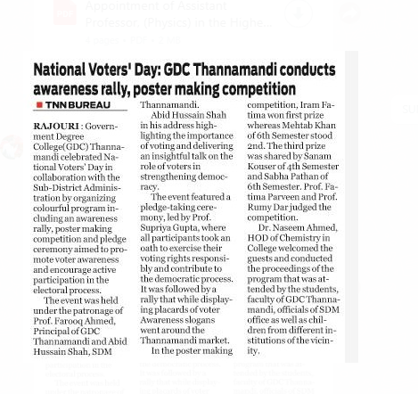
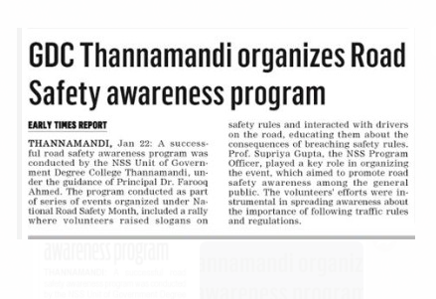

NSS Volunteer participated in 4-day Capacity Building Programme at Chandigarh
Organized by: RGNIYD RC Chandigarh
Venue: RGNIYD Regional Centre, Chandigarh
Date: 04-07 February 2025
NSS Volunteer Mehtab Khan from Government Degree College (GDC) Thannamandi actively participated in the 4-day Capacity Building Programme on Youth Employability Skills held at RGNIYD Regional Centre, Chandigarh, from 4th to 7th February 2025.
The programme aimed to equip youth with essential employability skills, including communication, leadership, problem-solving, and career development strategies. Mehtab Khan’s participation in the training reflects his dedication to enhancing his skill set and contributing to the overall growth of the NSS unit at GDC Thannamandi.
Under the guidance of Principal Prof. Dr. Farooq Ahmed and the supervision of NSS Program Officer Supriya Gupta, Mehtab Khan successfully completed the training, gaining valuable insights into youth empowerment and career readiness.
Such training initiatives play a crucial role in preparing students for future challenges by enhancing their professional skills and confidence. The participation of NSS volunteers in such programmes reinforces the commitment of GDC Thannamandi towards youth development and capacity building.
The event concluded successfully, with participants expressing their gratitude for the opportunity and their commitment to applying the acquired skills in their future endeavors.

- Participation of NSS Volunteers in Blood Donation Camp on 20/2/2025
Organized by: NSS Unit in collaboration with JK Thalassemia Welfare Society Jammu
Venue: University of Jammu
Date: 20/02/2025
Two NSS volunteers from Government Degree College (GDC) Thannamandi, Umar Gul and Anees Ahmed Khan, both students of BA/BSc Semester 6th, actively participated in this noble cause. They donated a total of two units of blood, demonstrating their commitment to social service and community welfare.
The volunteers were encouraged by NSS Program Officer (PO) Supriya Gupta, with the esteemed guidance of Principal Prof. Dr. Farooq Ahmed. The NSS volunteers of GDC Thannamandi have set an example for their peers by contributing to a humanitarian cause, reinforcing the values of social service and community engagement.
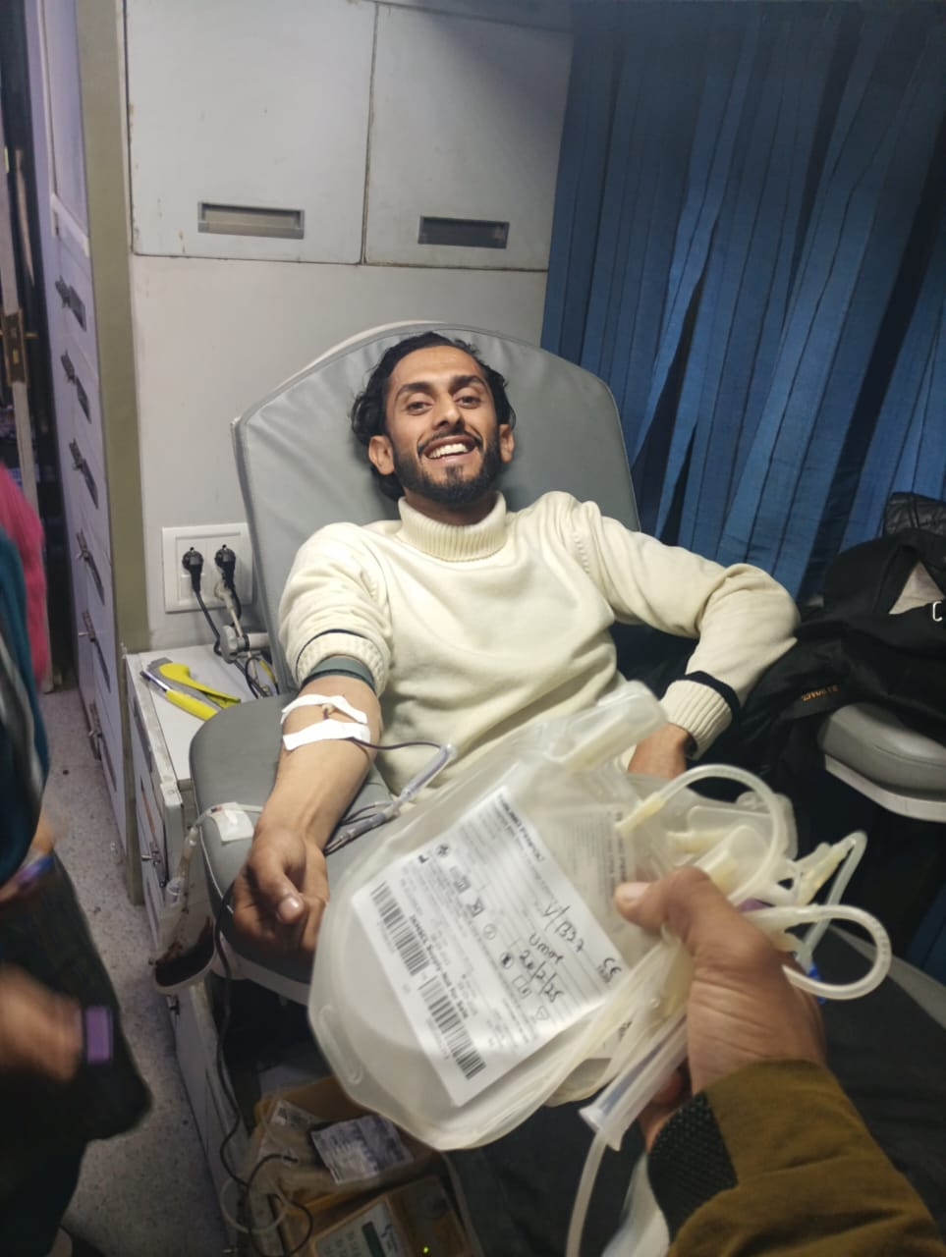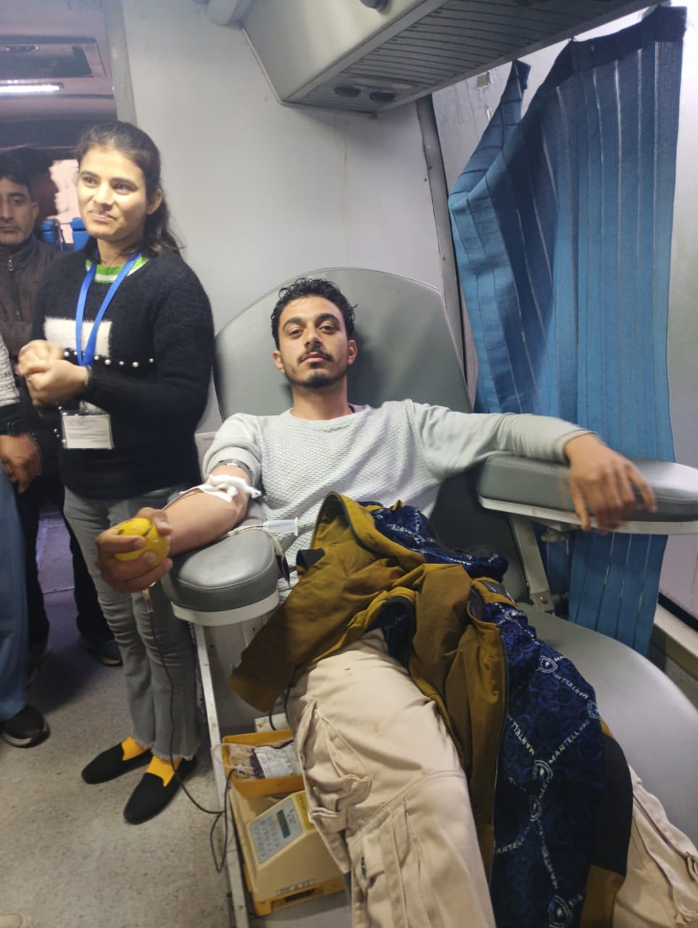

- Celebration of International Women’s Day March 8th 2025

International Women’s Day is a global day celebrating the social, economic, cultural and political achievements of women. The day also marks a call to action for accelerating gender parity.With the Theme 'Accelerate Action”, Women Development Cell in collaboration with NSS Unit of the College celebrated International’s Women’sDay 2025 with a message focusing on the need to Accelerate Action emphasizing the importance of taking swift and decisive steps to achieve gender equality. It calls for increased momentum and urgency in addressing the systemic barriers and biases that women face, both in personal and professional spheres. The event was organized under the esteemed supervision of the principal of college, Prof. Dr. Farooq Ahmed, aimed to empower and celebrate the achievements of women in society.

In this connection, a series of activities were organized from8th-11th March 2025 by the Women Development Cell in collaboration with the NSS unit of the College.

Activities Performed: -

SYMPOSIUM: TOPIC “WOMENS’ CONTRIBUTIONS TO CONSTITUTION MAKING

EXTENSION LECTURE BY PROF NAGINA KOUSER, HEAD DEPARTMENT OF ECONOMICS

POSTER COMPETITION: TOPIC EMPOWERING WOMEN

SPECIAL COUNSELING SESSION ON HEALTH AND HYGIENE

SYMPOSIUM: TOPIC “WOMENS’ CONTRIBUTIONS TO CONSTITUTION MAKING
To mark the Day a symposium on the topic "Role of Women in Constitution Making" organized by under the proficient guidance of Principal of College, Prof. (Dr.) Farooq Ahmed wherein Abid Hussain Shah, Sub-Divisional Magistrate, Thannamandi was Chief Guest and Qadeer Charak, Block Development Officer, Thannamandi, a Special Guest.In the Symposium that was aimed to inspire and empower women to take an active role in shaping the country's future, Amreen Qureshi won first prize whereas Afsana Kouser and Kamran Mumtaz bagged 2nd and third position respectively. The jury members included Dr. Nazar Ul Islam, Dr. Gulshan Rashid Bha and Dr. Shiraz Ahmed.The event featured the participation of students of GDC Thannamandi who shared their views on the topic.

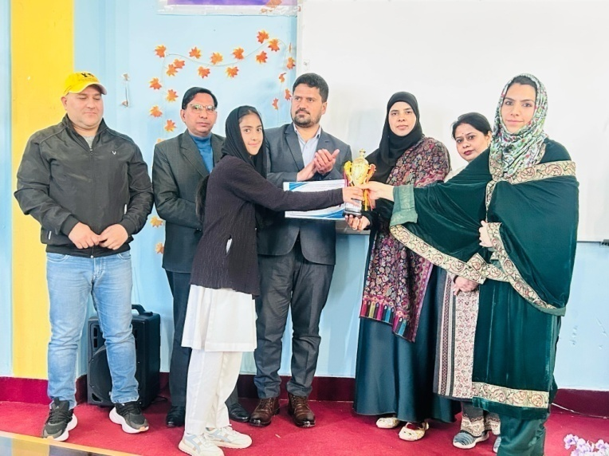
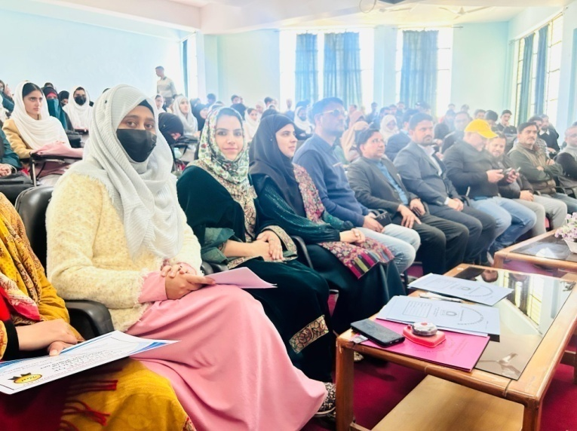

2. EXTENSION LECTURE BY PROF NAGINA KOUSER, HEAD DEPARTMENT OF ECONOMICS
Prof Nagina Kouser, Head of Economics Department, delivered an extension lecture on accelerating women empowerment action and their role. Jnb Abid Hussain Shah, SDM Thannamandi highlighted the importance of women's participation in governance and decision-making processes. Qadeer Charak, BDO Thannamandi emphasized upon the need for women's empowerment and education to achieve sustainable development. Dr. Farooq Ahmed spoke about the role of women in education and their contributions to the field of academics.
Earlier, Prof. Fatima Parveen, Convener WDC, introduced the audience about the programme and welcomed the guests. She emphasized upon the need to accelerate action from one’s own home. Prof. Rizwana conducted the proceedings and Prof. Rumi Dar, a member of the organizing committee, played a crucial role in making the event a success. Prof. Supriya Gupta, NSS PO, presented the vote of thanks. Administration and Principal of the college also appreciated the efforts of organizers in making this event a huge success. The presence of all faculty members and students make this event a huge success.
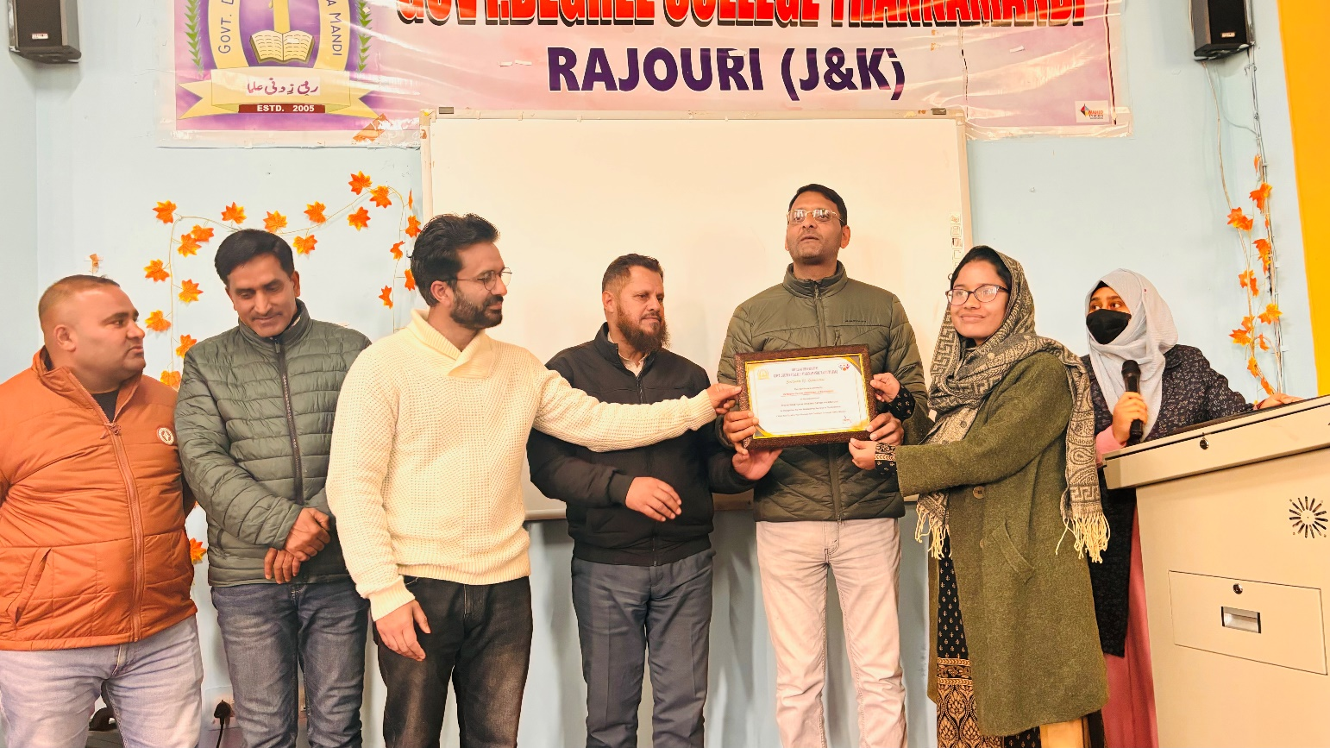

POSTER COMPETITION: TOPIC EMPOWERING WOMEN
A poster making competition on the theme “Empowering Women”held on March 10.In the poster making competition, Sultana Kouser won first prize whereas Sanam Kouser and Irtiqa Firdous Naik bagged 2nd and 3rd position respectively. The judges for poster making competition include Dr. Abdul Haque Naimi, Dr. Junaid Ahmed and Prof. Altaf Hussain. Students participated with full enthusiasm and prepared beautiful poster based on the theme. The poster of the students showed the different aspects of women’s life and spread a beautiful message with their creativity.
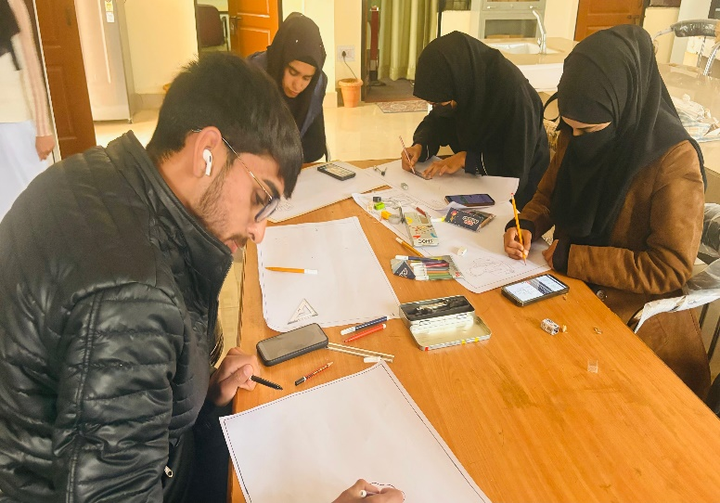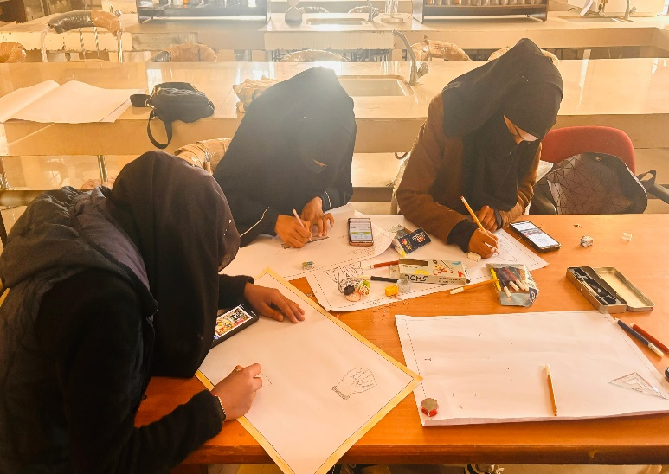

- SPECIAL COUNSELING SESSION ON HEALTH AND HYGIENE
A special counseling and health awareness programme for girl students and female staff members of college was also part of celebrations.The event garnered massive participation from NSS volunteers, NCC cadets, and students of the college. The major objectives of the eventwere
- To increase awareness among adolescent girls on Menstrual Hygiene
- To increase access to and use of high-quality sanitary napkins to adolescent girls in rural areas.
- To ensure safe disposal of Sanitary Napkins in an environmentally friendly manner.
Prof. Fatima Parveen along with other faculty members aware the girls about the importance of cleanliness, health and hygiene followed by the valedictory session, where Dr. Nazakat Hussain, Head Department of History was Chief Guest wherein female faculty members, winners, participants and female toppers were felicitated.Earlier, Prof. Fatima Parveen, Convener WDC, introduced the audience about the programme and welcomed the guests. Prof. Rizwana Kousar conducted the proceedings of programme whereas Prof. Rumi Dar presented the formal vote of thanks. Prominent among others present on the occasion were Dr. Naseem Ahmed, Dr. Abdul Haque Naimi, Rakesh Puri, Dr.NazarUl Islam, Dr. Goher Iqbal, Prof. Altaf Hussain, Dr. Junaid Ahmed, Dr. Gulshan Rashid Bhatt, Dr. Sheraz Ahmed, Dr. Ather Aziz Raina, Dr. Nagina Kouser, Dr. Mohd Arshad, Dr. Sarfaraz Hussain, Dr. Atiq Ul Rehman, Dr. Mohd Shakoor, Dr. Showkat Ahmed and Dr. Wahid Ahmed Qazi.

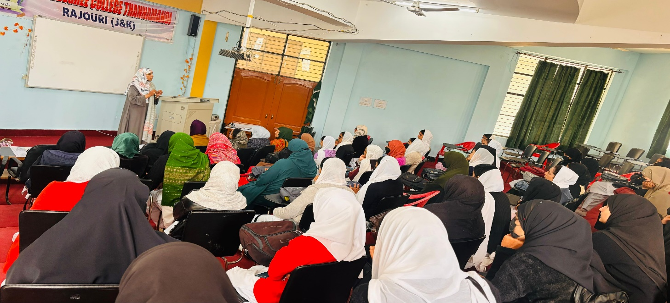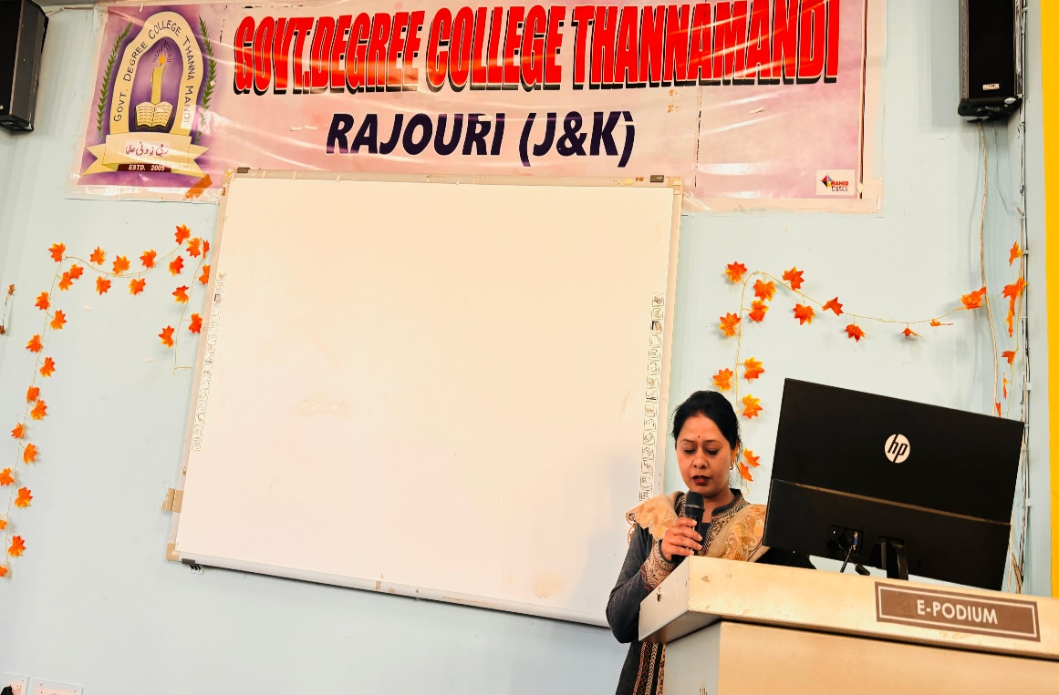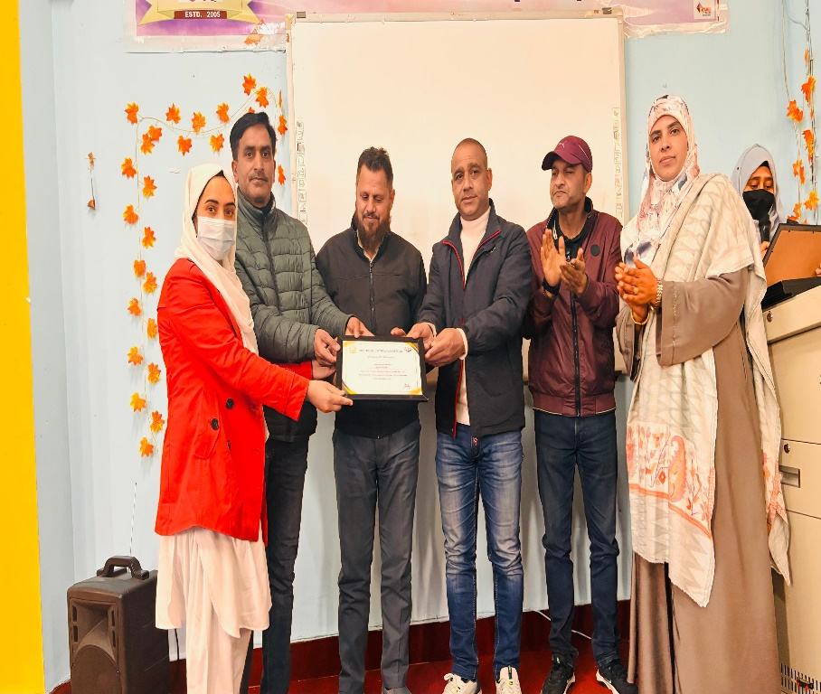
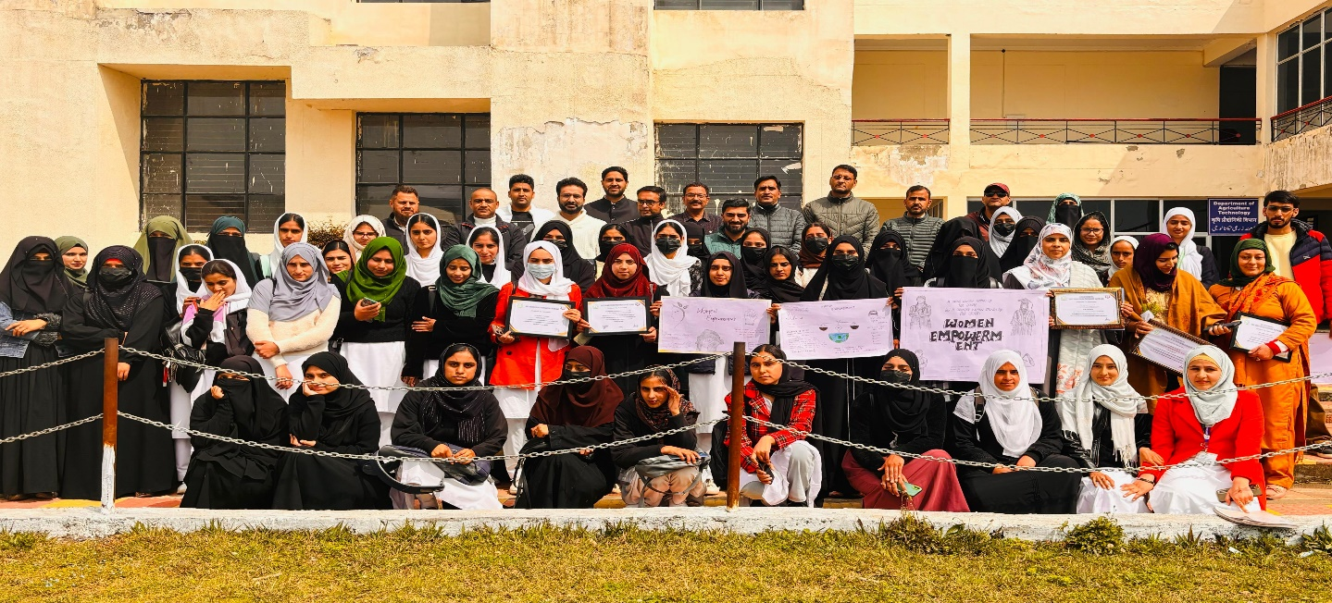

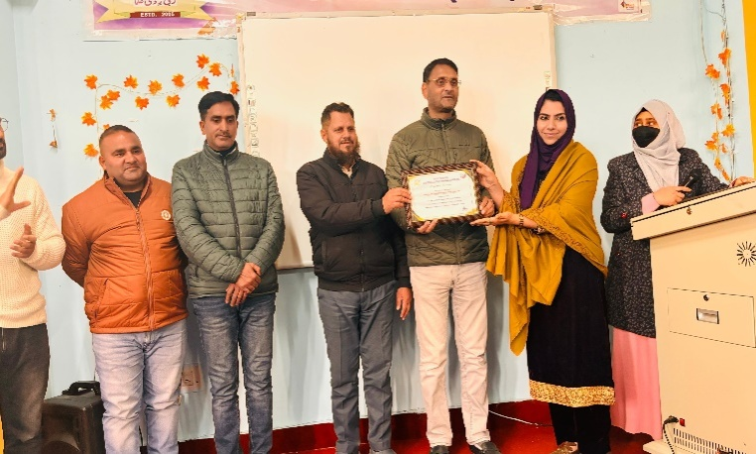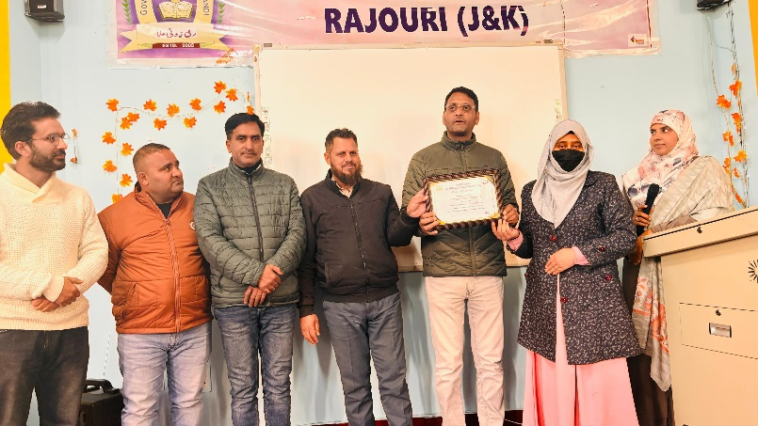

- NSS Volunteers' Participation in Viksit Bharat Youth Parliament
Introduction
The Viksit Bharat Youth Parliament is a prestigious platform that encourages young minds to actively engage in discussions on key national issues. The event aims to develop leadership skills, enhance public speaking abilities, and promote awareness of democratic processes among students. NSS volunteers from Govt. Degree College Thannamandi, participated in this initiative with great enthusiasm and commitment.
Participation and Selection Process
A total of 16 NSS volunteers from the college registered for the event by uploading one minute video on the topic “What Viksit Bharat Means to You?”. Videos are uploaded on the college youtube Channel @Govt.DegreeCollegeThannamandiR. After a rigorous selection process students were chosen to represent the institution at the District-Level Youth Parliament, held at Government P.G. College, Rajouri. The selection was based on their knowledge of the topic, articulation, and debating skills.
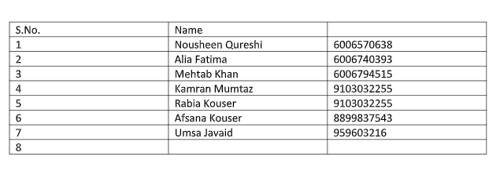
The District-Level Youth Parliament witnessed insightful discussions on the topic "One Nation, One Election: Paving the way for Viksit Bharat" Under the expert guidance of NSS Program Officer, Supriya Gupta, the participants displayed confidence and excellent debating skills. Their well-researched arguments and articulate presentations were highly appreciated by the jury.
Achievements
The outstanding performances of the NSS volunteers led to notable achievements that one of volunteer Kamraan Mumtaz made it to the State level Youth Parliament at University of Jammu. One O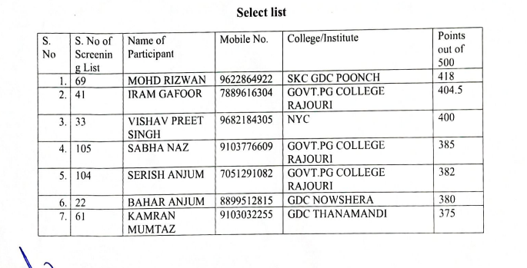
Kamran Mumtaz was selected for the State-Level Youth Parliament, bringing pride to the institution.
Aalia Fatima earned a position on the waitlist, reflecting her commendable performance.
Impact and Conclusion
The participation of NSS volunteers in the Viksit Bharat Youth Parliament highlighted their dedication to national issues and public discourse. The event provided them with an opportunity to hone their leadership skills and contribute meaningfully to discussions on governance and democracy. Their achievements underscore the importance of youth engagement in shaping India's future.
The NSS unit of Government P.G. College, Rajouri, remains committed to fostering such opportunities for students and looks forward to greater participation in future events.

